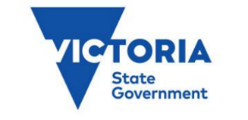

State Maritime Emergencies
(non-search and rescue) Subplan
Edition 2

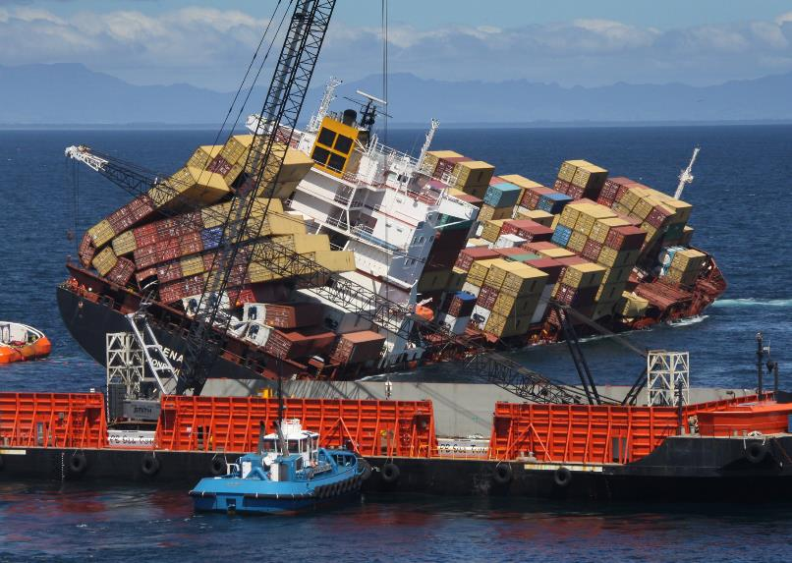

Authorised and published by the Victorian Government
Published Melbourne October 2021
© State of Victoria 2021
You are free to re-use this work under a Creative Commons Attribution 4.0 licence, provided you credit the State of Victoria (Department of Transport) as author, indicate if changes were made and comply with the other licence terms. The licence does not apply to any images, photographs or branding, including Government logos.
An electronic version of the subplan can be obtained at www.emv.vic.gov.au
ISBN 978-0-7311-9197-0 (pdf/online/MS word)

Acknowledgement of Country
The Victorian Government acknowledges Aboriginal and Torres Strait Islander people as the Traditional Owners and custodians of the land and acknowledge that the land and sea is of spiritual, cultural and economic importance to Aboriginal people.

Contents

1 Introduction 5
1.1 Purpose 6
1.2 Scope 6
1.3 Objective 7
1.4 Authorising environment 7
1.5 Activation of the subplan 7
1.6 Audience 8
1.7 Linkages 8
1.8 Review 8
2 The emergency context 10
2.1 What is a maritime emergency? 10
2.2 Risk profiles 11
2.3 Risk mitigation 19
3 Management of maritime emergencies (non-search and rescue) 24
3.1 Victorian governance arrangements 24
3.2 Key state and national control and coordination roles 26
3.3 Response and recovery 29
3.4 Control 36
3.5 Communications 47
4 Capability and resource management 50
4.1 Responsibilities of marine pollution control agencies 50
4.2 Capability development 53
5 Appendices 56
5.1 Appendix 1 - Authorising legislation 56
5.2 Appendix 2 - Victoria’s commercial trading ports 61
5.3 Appendix 3 - Victoria’s local ports 62
5.4 Appendix 4 - Jurisdictional boundaries and maps 63
5.5 Appendix 5 - Glossary 65
5.6 Appendix 6 - Acronyms 71

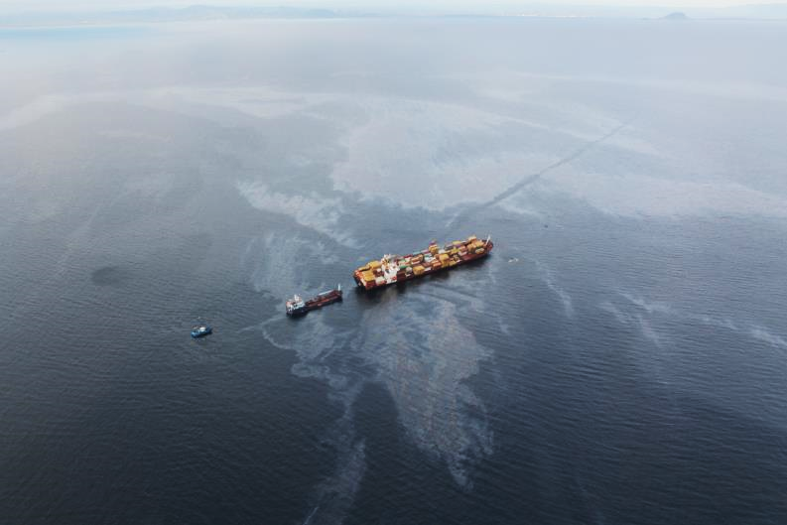

- Introduction

Complex maritime emergencies (non-search and rescue) are a significant threat to the state’s marine environment. The impacts of a Class 1 or 2 emergency would have catastrophic consequences to life (including aquatic life), maritime and state operations, infrastructure, the economy and the environment.
The emergency management arrangements outlined in this plan are crucial to ensure that government, industry and community confidence is maintained. Understanding the state’s capability is essential for preparedness, planning, response and recovery to a maritime emergency.
No single agency has the capacity or resources (including skilled staff) to respond to and manage a complex maritime emergency; this will require resource allocation from multiple jurisdictions.
This subplan exists to ensure that collaboration, co-operation and resources sharing is captured and agreed to by the stakeholders and a response to a complex maritime emergency will be a shared responsibility between the agencies.
The Maritime Emergencies (Non Search and Rescue (NSR)) Subplan of the State Emergency Management Plan (SEMP) is developed in accordance with the Emergency Management Act 2013, it also serves the purposes of being the Victorian Marine Pollution Contingency Plan in accordance with the Marine (Drug, Alcohol and Pollution Control) Act 1988 (the Act).
The subplan is two parts:
- Part A is the Maritime Emergencies (NSR) Subplan:
- It provides an overview of the arrangements for managing maritime emergencies in Victoria.
- It describes the integrated approach and shared responsibility between state and commonwealth governments, agencies, businesses and communities.
- The Subplan refers to national agreements, plans and documents, including the National Plan.
- Part B is the Maritime Emergencies (NSR) Operational Plan and contains the operational details for preparing and planning for, responding to, and recovering from maritime emergencies.
The subplan applies to maritime emergencies (NSR) including marine pollution which results or may result in a prohibited discharge of oil, oily mixtures, undesirable or hazardous and noxious substances into state waters.
This edition of the Victorian Marine Pollution Contingency Plan is developed, coordinated and administered by the Secretary, Department of Transport (DoT) in accordance with Section 71A of the Act.
This edition has been prepared by DoT, in collaboration with control agencies and organisations which have Maritime Emergency (NSR) responsibilities.

1.1 Purpose
The purpose of this subplan is to:
- Provide the Victorian Marine Pollution Contingency Plan in accordance with section 71B of the Marine (Drug, Alcohol and Pollution Control) Act 1988 to ensure there is adequate planning and preparation for marine pollution incidents (including by providing equipment and training personnel).
- Give effect to Victoria’s obligations under the National Plan for Maritime Environmental Emergencies and Intergovernmental Agreements.
- Provide the State Emergency Management Plan Maritime Emergencies (NSR) Subplan in accordance with the Emergency Management Act 2013.
- Provide strategic guidance for the effective management of maritime emergencies specifically addressing marine pollution (including oil and hazardous noxious substances) and/or maritime casualty NSR.

1.2 Scope
The scope of this subplan is maritime emergencies that are:
- marine pollution by oil, oily mixtures, and undesirable substances
- marine pollution by hazardous and noxious substances (HNS)
- maritime casualties (i.e. vessels – non search and rescue)
- wildlife affected by marine pollution
Geographically, this subplan applies to maritime emergencies (NSR) in Victoria’s embayment’s (enclosed waters) and state coastal waters up to 3 nautical miles.
This subplan does not cover the following hazards [Indicates responsible agency]:
- Pollution in commonwealth waters from petroleum titleholders or offshore petroleum facilities [National Offshore Petroleum Safety and Environmental Management Authority (NOPSEMA)].
- Cetacean entanglements or strandings and vessel strikes [Department of Environment, Land, Water and Planning (DELWP)].
- Blue Green Algal Blooms [DELWP].
- Maritime search and rescue and evacuation [Victoria Police (VICPOL)].
- Ship-board fires [Country Fire Authority (CFA) or Fire Rescue Victoria (FRV)].
- Public health, mass human casualty [Department of Health (DH)].
The direct management of these hazards is not within scope of this subplan, however the control and coordination principles may be applied, where the hazard is concurrent with other hazards that are under the scope of this subplan.

1.3 Objective
The objective of the subplan is to:
- ensure an integrated and coordinated approach to Victoria’s management of maritime emergencies (NSR); and
- reduce the impact and consequences of maritime emergencies (NSR) on communities, infrastructure and services, and the environment.

1.4 Authorising environment
This subplan has been prepared by the Department of Transport (DoT), on behalf of the Emergency Management Commissioner (EMC), and in accordance with:
- Marine (Drug, Alcohol and Pollution Control) Act 1988
- Marine Safety Act 2010
- Part 6A of the Emergency Management Act 2013
- State Emergency Management Plan
- Australian Maritime Safety Authority (AMSA) National Plan for Maritime Environmental Emergencies 2020 Edition
- AMSA’s Intergovernmental Agreement on the National Plan to Combat Pollution of the Sea by Oil and other Noxious and Hazardous Substances (2002)
- Intergovernmental Agreement on the National Maritime Emergency Response Arrangement (2008)

1.5 Activation of the subplan
The arrangements in this plan apply on a continuing basis and do not require activation.

1.6 Audience
The audience for this subplan is Victorian government departments and agencies within the emergency management sector who have responsibilities under the subplan, as well supporting businesses, contractors and local government authorities.

1.7 Linkages
This subplan reflects legislation, the arrangements in the SEMP, the strategic direction for emergency management in Victoria, accepted state practice for managing emergencies, and the related national and international protocols, conventions and arrangements as listed in Appendix 1.
This subplan should be read in conjunction with:
- The National Plan for Maritime Environmental Emergencies for incidents which occur in commonwealth waters for marine pollution including hazardous and noxious substances and maritime casualties.
- The Victorian Marine Search and Rescue Arrangements.
- The Operation Plan (PART B)

1.8 Review
The original Edition of the subplan was authorised and published in 2016 by the former Department of Economic Development, Jobs, Transport and Resources (DEDJTR).
Edition 2 (this edition) was reviewed and updated by the Department of Transport (DoT) (under Part 6A of the Emergency Management Act 2013) and in consultation with maritime emergencies stakeholders and control agencies.
Edition 2 is current at the time of publication and remains in effect until modified, superseded or withdrawn by the Secretary, DoT. The subplan will be reviewed every three years or as agreed by the Secretary, DoT.

PART A - STATE EMERGENCY MANAGEMENT PLAN, MARITIME EMERGENCIES (NSR) SUBPLAN

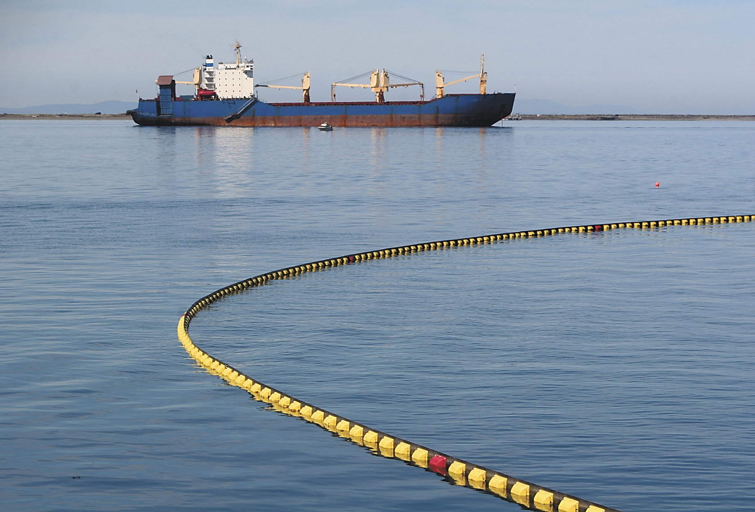

- The emergency context

2.1 What is a maritime emergency?
For the purpose of delineating roles and responsibilities under this subplan, maritime emergencies are divided into four categories:
- Maritime casualty
- Oil spills (from ship sources or as a result of petroleum exploration or production)
- Hazardous and noxious substance spills
- Wildlife affected by marine pollution events

The possibility of a maritime emergency affecting Victoria arises from oil and gas production, commercial shipping, domestic and recreational vessel activity, and naturally occurring events.
The consequences of major maritime emergencies can include loss of marine habitats and wildlife, economic losses due to impacts on commercial shipping and tourism, and social impacts due to the loss of amenity or access to coastal areas.
The risk of maritime emergencies comes from a number of sources:
- Oil and gas industry
- Commercial shipping
- Domestic vessel activities

2.2 Risk profiles

2.2.1 Oil and gas industry
Offshore petroleum production occurs in commonwealth waters off Victoria in two major sedimentary basins: the Gippsland and Otway basins.
The Gippsland Basin covers an area of 46,000 km² and has both onshore and offshore components (over 60% is located offshore). For more than thirty years, the Gippsland Basin has produced natural gas, crude oil and condensate and is a mature petroleum province.
The Otway Basin also has both onshore and offshore components and produces natural gas and condensate. It covers approximately 155,000 km², with around 80% of the basin being located offshore.
Natural gas, crude oil and other production fluids are moved by pipeline, vessel and road transport for further processing and/or to service consumers’ needs both locally in Victoria and nationally across Australia.
There are a significant number of manned and unmanned platforms and installations in commonwealth waters in Bass Strait, as well as an extensive network of underwater pipelines, transporting production fluids ashore. These are owned and operated by private companies known as titleholders. In commonwealth waters, titleholders are regulated by the National Offshore Petroleum Safety and Environmental Management Authority (NOPSEMA).
NOPSEMA also regulates all offshore areas in coastal waters where a state or the Northern Territory has conferred regulatory powers and functions. In jurisdictions where powers to regulate are not conferred, regulatory responsibilities remain with the relevant state or territory, in Victoria this is through the Department of Jobs Precincts and Regions (DJPR).
The Australian Marine Oil Spill Centre (AMOSC) manages oil spill response activities and equipment stockpiles on behalf of the Australian oil and gas industry and are available for rapid response anywhere around the Australian coast on a 24/7 basis.

2.2.2 Risk of maritime casualty
Maritime casualty risks arise when a vessel is unable to:
- independently maintain a safe distance from surrounding navigational hazards (i.e. coastline, outlying islands and reefs, other vessels and offshore structures);
- effectively maintain the integrity of its cargo (through fire, explosion or water ingress) and to effectively contain its cargo (including any fuel or oil) carried on board.
Casualty risk may be categorised as:
- breakdown – failure of equipment essential to the independent navigation of the vessel or the maintenance of integrity of its cargo, rendering it in need of external assistance
- fire or explosion – damage to equipment essential to the independent navigation of the vessel or the maintenance of integrity of its cargo, rendering it in need of external assistance
- collision – two vessels coming together inadvertently causing significant damage
- stranding – a vessel inadvertently making contact with the seabed and being unable to independently free itself
- contact – a vessel striking a fixed object
The risk of maritime casualty is greatest due to vessel disablement, groundings, collisions and close quarters situations. A close quarters situation is one in which two vessels or a vessel and an object come close enough to risk a collision.
An emerging risk around maritime casualty is towage capability and availability to handle larger and heavier ships being used.

Shipping activity
In a world of global connection and trade, Australia relies heavily on commercial shipping activities, both nationally and internationally for the importing and exporting of goods.
In 2016–17, Australia imported 99.3 million tonnes of goods by sea, worth $193.1 billion, and exported by sea $252.1 billion worth of goods. A total of 653 million tonnes of cargo moved across Australian wharves in 2016-17. The average annual trend growth over the five-year period since 2011–12 was 7.4 per cent.
Victoria receives more than 4,250 port calls from cargo ships each year, loading and discharging more than 12.8 million tonnes of freight. The relative density of ship traffic is greatest at the commercial ports (profiled in Appendix 2), in particular Port Phillip Bay (Figure 1). Other areas of concentrated vessel activity include the approaches to Port Phillip Bay and the waters off Wilsons Promontory.
The Australian Maritime Safety Authority (AMSA) has a national incident reporting system for marine incidents.
Figure 1. Indicative vessel traffic density map for the Victorian coast and offshore 2019
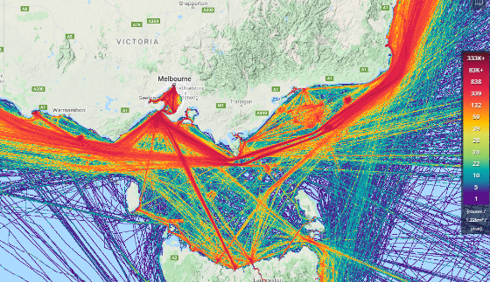

Lowest density purple, grading to highest density in red. (Source: Marine Traffic www.marinetraffic.com accessed February 2020).

Domestic commercial marine incidents
There are approximately 22,000 active Domestic Commercial Vessels (DCV) operating in Australia. Around 8.6% of the vessels are located and operate from Victoria¹.
AMSA data shows that for the year of 2019, there was a total of 741 DCV marine incidents reported. Of these 264 were due to contacts/collisions, with around 26 (9.9%) occurring in Victoria¹.
The consequences of a ship maritime casualty may include loss of life, the ship, its cargo or fuel, and potentially cause marine pollution.
It should be noted that over the last ten years DCV incident reporting systems and legislation have changed significantly which means gathering long term comparable data on incidents is difficult. Research also shows there is a need to improve reporting systems as there is evidence of under reporting of incidents for several reasons, including fear of disciplinary or compliance action, a lack of understanding of what constitutes a reportable incident or the importance of reporting, and complexity in reporting.

Regulated Australian and foreign flagged vessel marine incidents
Between 2016 and 2019, 4909 unique vessels were associated with 12,349 marine incident reports. Bulk carrier ships are highly represented in marine incident reports, making up over 50% of all reports over four years (Figure 2).

Figure 2. Distribution of reported incidents and port arrivals by vessel type and year nationally (2016 to 2019)
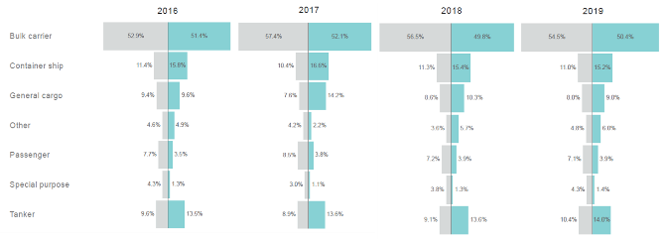

Recreational vessel activity
Domestic and recreational vessels also pose a risk of maritime casualty. Although the consequences may not be as severe as a ship casualty, they occur more frequently and can have similar consequences of loss of life, the vessel and impacts of a fuel spill on a local scale.
Victoria has close to 200,000 registered recreational vessels. The majority of vessels are highly mobile (trailable) and 96 per cent are vessels less than eight metres. Local ports support recreational boating, which is an increasingly popular pastime for many Victorians.
Victoria has 14 local ports with eight local port managers (Appendix 3). Local ports provide services to the oil and gas industry, commercial fishing industry, charter boats, and recreational fishing and boating interests. The ports are key recreational and tourist assets and contribute significantly to local and state economies.

Recreation vessel marine incidents
The number of reported recreational vessel incidents has been relatively constant over the past decade, with 1,100 of the 1,300 reported incidents each year involving disabled vessels (Figure 3).

Figure 3. Number of reported recreational vessel incidents in Victoria 2009-2019
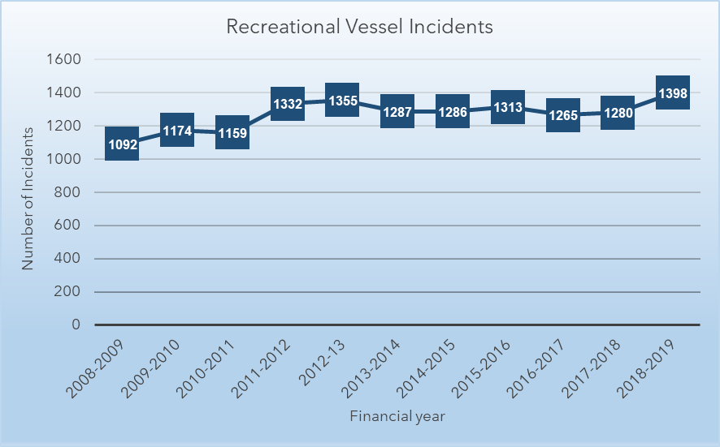

2.2.3 Risk of marine oil pollution
Marine oil pollution spills may occur as consequence of a maritime casualty, bunkering operations, from oil and gas production activities or illegal dumping from ships.
The last comprehensive Victorian marine risk assessment was conducted in 2011, since then a number of factors that affect Victoria’s risk profile of oil spills from tankers have changed. These factors include the decommissioning of offshore facilities in Bass Strait, closure of refineries (reducing crude imports and increasing refined fuel imports), less oil production occurring and more gas production.
There is an increase in the size of ships and the volumes and type of cargo and fuel that they carry.
Increases in ship to ship transfers within state and port waters is an emerging risk which may affect the risk of marine pollution in the future.
Table 1 shows the history of significant oil spills in Australia causing environmental or economic losses over the last 20 years.

Table 1. History of significant or major oil spills in or near Australian waters
Date | Vessel | Location | Oil amount
August 1999 | Laura D’Amato | Sydney, NSW | 250 tonnes
December 1999 | Sylvan Arrow | Wilson's Promontory, VIC | less than 2 tonnes
September 2001 | Pax Phoenix | Holbourne Island, QLD | less than 1000 litres
December 2002 | Pacific Quest | Border Island, QLD | greater than 70 km slick
January 2006 | Global Peace | Gladstone, QLD | 25 tonnes
March 2009 | Pacific Adventurer | Cape Moreton, QLD | 270 tonnes
August 2009 | Montara oil platform | NW Australian coast, WA | Approx 4,750 tonnes
April 2010 | Shen Neng 1 | Great Keppel Island, QLD | 4 tonnes
January 2012 | MV Tycoon | Christmas Island | 102 tonnes
March 2014 | Unknown source | Golden Beach, VIC | unknown

Another significant change occurred on 1 January 2020, when all ships and vessels operating anywhere in the world were required reduce their emissions of sulphur oxide (SOx) by either using fuel oil with a maximum sulphur content of 0.5 per cent m/m or installing an approved exhaust gas cleaning system. These measures aim to reduce the impacts of (SOx) emissions from shipping on the environment and human health. Coal-powered ships are now almost entirely heritage vessels.
With the global increase in the use of low and very low sulfur fuel oils (VLSFO) in ships, and being transported, the traditional response strategies (dispersants, burning, booms) used for oil pollution cleanup may no longer be as effective. Therefore, spills involving low or VLSFO may require changes in traditional operational strategies for response and clean up.
Taking the changes in shipping activities outlined into consideration and using the previous 2011 marine risk assessment as a baseline (Figure 4), the risk of tanker oil spills is likely to have decreased somewhat, noting though, the use of VLSFO, and that bulk carriers and container vessels may not have double hull protection for their bunker tanks.
The changes, however, do not alter the consequences of a spill if it did occur, and the devastating impact it could have on marine and shore habitats, amenities, heritage areas, the economy, or vulnerable and threatened species.
Figure 4. Distribution of marine pollution risk on the Victorian coastline

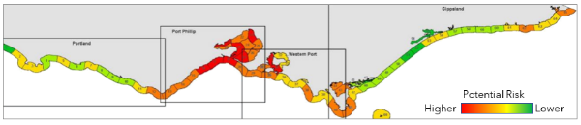

2.2.4 Risk of hazardous and noxious substance (HNS) spills
HNS spills may occur as the result of a maritime casualty, accidents occurring during loading or unloading, or as illegal discharges at sea. Sections 2.2.2-3 ‘Risk of maritime casualty and marine oil pollution’ are also relevant to the risk of HNS spills occurring.
Packaged HNS are carried on container ships in special storage tanks, housed within a 20 foot ISO container-sized frame, or stored in drums and loaded into standard shipping containers. If these containers become dislodged during transit, they may break open and leak, or entire containers may be lost overboard. Containers, drums or other packages containing chemicals occasionally wash up on shore, posing a potential risk to the public and environment.
When highly reactive chemicals are allowed to mix with water, air or other chemicals, there is the potential for violent reactions, explosions, fires or release of toxic vapours to occur. The consequences to the safety of the ship, its personnel and the public may be severe, even though there may be little risk from a spill into the environment.
Safety standards are in place regarding stowage and segregation of HNS to reduce the risk of chemicals interacting while stored on board vessels. Accredited training is also available to crew and shoreline personnel in the handling of HNS.
Part B of the subplan provides details on the control and response to HNS incidents.

2.2.5 Wildlife affected by oil and HNS
DELWP is the lead agency for responding to wildlife impacted by marine and freshwater pollution.
In the event of an oil or HNS marine pollution emergency, large numbers of wildlife, particularly seabirds and marine mammals may be affected. Threatened species and marine ecosystems could also be impacted.
Risks are greatest at breeding and feeding locations such as coastal wetlands, mudflats and offshore islands (some examples include the Ramsar listed areas of Port Phillip, Gippsland Lakes, Western Port and Corner Inlet, Phillip Island, Lady Julia Percy Island, Gabo Island and Logans Beach whale nursery).
DELWP, with support from partner agencies (such as Parks Victoria and Phillip Island Nature Park), will assess the welfare needs of wildlife during an emergency and determine and lead wildlife response activities.

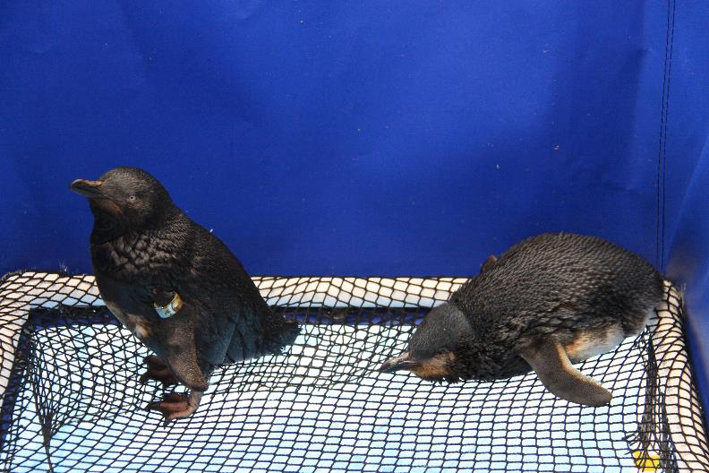

2.3 Risk mitigation
Maritime Emergencies are classified as a Class 2 Emergency under the Emergency Management Act 2013.
The relevant control agency works with the Emergency Management Commissioner, Emergency Management Victoria, other government agencies, industry, and the community to reduce and mitigate the consequences of a maritime emergency on the community.
Mitigation of maritime emergency risk is largely achieved through industry construction standards, and legislation and regulation. The Marine Safety Act 2010 provides for safe navigation rules, port operations procedures and maritime qualification requirements, such as local knowledge certificates and recreational vessel licensing. These involve state, national, and international rules, agreements and arrangements to be in place (Appendix 1). The application of agreements and arrangements to mitigate maritime emergency risk, is largely beyond the scope of this subplan.

2.3.1 Industry Standards
A range of international conventions exist to provide standards and measures which help prevent maritime emergencies. Australia is signatory to the International Maritime Organisation’s (IMO) International Convention for the Prevention of Pollution from Ships 1973 and International Convention on Oil Pollution Preparedness, Response and Cooperation. Further information on international conventions can be found in Appendix 1.
The AMSA National System for Domestic Commercial Vessel Safety provides a consistent approach to safety for owners, operators, and crew of commercial vessels working in Australia and has been designed to improve marine safety and make it easier for seafarers and their vessels to work around Australia. The national system ensures commercial vessels working in Australia have a certificate of survey and a certificate of operation. Crew working on commercial vessels must also have a certificate of competency.

2.3.2 Safe navigation

Vessel traffic services
In accordance with international conventions, AMSA issues Vessel Traffic Services (VTS) ‘Instruments of Authority’ to approved providers to manage, operate and coordinate vessel movements.
VTS services contribute to safety of life at sea, the safety and efficiency of vessel navigation, and the protection of the marine environment, the adjacent shore area and worksites from possible adverse effects of maritime traffic.

Harbour masters
Where a harbour master is appointed within commercial or local ports, all shipping movements within the port waters are controlled by the harbour master. Under the Marine Safety Act 2010 the harbour master’s main functions are to control and direct:
- vessels entering and leaving the waters for which they have been engaged;
- the navigation and other movement of vessels in those waters;
- the position where and the manner in which any vessel may anchor or be secured in those waters;
- the time and manner of the taking in or discharging from any vessel of cargo, stores, fuel, fresh water and water ballast in those waters;
- the securing or removal of any vessel in those waters in, from or to any position the harbour master thinks fit.
Harbour Masters have the powers to prohibit the entry to (or require removal of a vessel from) waters under their control if they believe it is:
- unseaworthy, or
- in imminent danger of sinking and causing an obstruction to navigation; or
- in imminent danger of causing serious damage to the marine environment or property in those waters.

Pilotage
The Marine Safety Act 2010 sets out pilotage requirements for vessels over 35m in length. It also allows the Director, Transport Safety to specify areas where the master of a vessel requires a local knowledge certificate. This applies to locations where it is considered local conditions provide a sufficient risk to vessel operations.

Navigation channel maintenance
Hydrographic surveys can be undertaken periodically to monitor channel cross sections, including the depth in existing ports and harbours, and any navigational hazards. These surveys inform periodical maintenance, issuing of Notices to Mariners and allows for the safe navigation of vessels.

2.3.3 Planning and regulation

Workplace safety
Workplace safety in and around ships is primarily regulated by the Victorian Workcover Authority (WorkSafe Victoria), Director Transport Safety and the Australian Maritime Safety Authority (AMSA). The Marine Safety Act 2010 promotes safe marine operations in Victoria by introducing marine safety duties, creating a ‘chain of responsibility’ for all parties who have a role in ensuring safety, and providing a framework to ensure vessels are fit for purpose and those who operate them have the skills to do so safely.

Port Safety and Environment Management Plans (PortSEMP)
The Port Management Act 1995 requires all local and commercial ports to prepare a Port Safety and Environment Management Plan (PortSEMP). PortSEMPs facilitate a whole-of-port approach to hazard and risk management, particularly for the interface between land and water in ports.

Port Emergency Management Plans
Certain ports, particularly commercial ports, prepare Port Emergency Management Plans which detail arrangements to achieve preparedness for, response to, and recovery from emergencies that could occur within the port. The plans are integrated with national, state and local (municipal) emergency management arrangements.

2.3.4 Assets and capability

Equipment
Victorian marine pollution response equipment (stockpiles) is strategically located around the state in accordance with response type and needs, with a focus on areas identified as high risk. Further details on stockpile locations are in the operational plan (Part B).
Victoria’s four commercial port operators have emergency marine pollution and maritime casualty (NSR) response arrangements in place for their designated waters. Arrangements may include local towage capability, such as tugs, smaller vessels and lifting cranes.
Personnel
The Emergency Management Act 2013 requires control agencies to maintain a trained, ready and capable emergency management surge workforce that is available to respond to an emergency event. This is supported by intergovernmental agreements and support arrangements as outlined in the SEMP.

2.3.5 Shared responsibility for action
Each member of the community has a role to play in the maritime emergency continuum (before, during and after an incident).
An example of an individual’s responsibilities within the maritime emergencies’ context, includes owners and masters of vessels taking responsibility for their vessel:
- ensuring it is seaworthy
- having appropriate safety systems in place
- having an emergency plan
- adhering to maritime laws, guidelines and protocols

For government agencies, businesses and industry, shared responsibility includes:
- marine safety awareness programs
- applying risk based regulation
- creating partnerships with industry to build capability and capacity
- ensuring an effective, well-coordinated response to emergencies
- helping communities affected by maritime emergencies to recover and build resilience for future events.
The principles of shared responsibly are listed in the Marine Safety Act 2010 which outlines that marine safety is the shared responsibility of:
a. owners of vessels; and
b. marine safety workers; and
c. persons involved in recreational boating activities; and
d. pilots and pilotage services providers; and
e. port management bodies, local port managers and port operators; and
f. other persons who:
i. design, commission, construct, manufacture, supply, install, maintain, repair or modify marine safety infrastructure, vessels or marine safety equipment; and
ii. supply marine safety infrastructure operations to port management bodies; and
g. the Safety Director; and
h. the public.
The level and nature of responsibility that ‘a person’ referred to above has for marine safety is dependent on the nature of the risk to marine safety that the person creates from the carrying out of an activity (or the making of a decision) and the capacity that person has to control, eliminate or mitigate that risk.
Further information is available to the community to assist them in preparing for maritime emergencies. General information can be found on the Marine Safety Victoria website.

Managing and protecting Aboriginal heritage places
The Victorian Government, and the agencies/organisations named in this subplan, acknowledge Aboriginal people as Australia’s first people, and as the Traditional Owners and custodians of the land.
Aboriginal and Torres Strait Islander people have a deeply spiritual, cultural and economic connection to the land and sea, which is reflected the Marine and Coastal Policy March 2020.
Aboriginal heritage places can be vulnerable to maritime emergencies, and it is important that the planning and preparing phases for maritime emergencies considers the impact on Aboriginal heritage places. Emergency response activities should work to protect, preserve and minimise disruption to Aboriginal heritage places.
It is recommended that relevant Traditional Owners be included in planning and response activities through direct participation in incident management teams (IMT) and that regional/local response plans should have pre-identified relevant Traditional Owner contacts and relationships well established, prior to an emergency incident occurring. Registered Aboriginal Parties can be found via https://www.aboriginalheritagecouncil.vic.gov.au/victorias-current-registered-aboriginal-parties
Where a Registered Aboriginal Party has not been appointed, advice on relevant Traditional Owner contacts can be provided by First Peoples State Relations.

3 Management of maritime emergencies (non-search and rescue)

3.1 Victorian governance arrangements
Victoria has an extensive set of legislation and plans that govern national, state and local responses to maritime emergencies, these are summarised in Appendix 1. The implementation of the legislation is supported by port directions, memoranda of understanding and emergency management standards and systems that operate across the Victorian emergency management sector.
The State Crisis and Resilience Council (SCRC) is responsible for approving Part A of this subplan as the SEMP Maritime Emergencies NSR Subplan.
Figure 5 shows the governance arrangements relating to maritime emergencies within Victoria and the linkages to the Regional Emergency Management Planning Committees (REMPC).

Figure 5. Governance arrangements relating to maritime emergencies within Victoria.
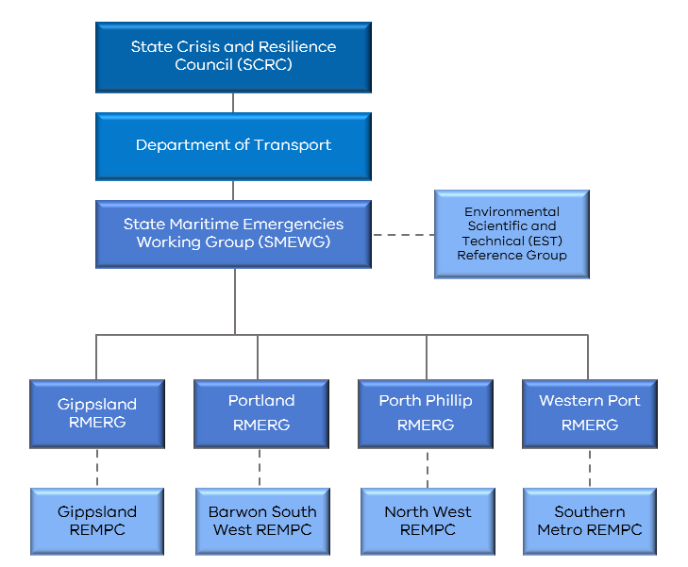

3.1.1 State Maritime Emergencies Working Group (SMEWG)
The State Maritime Emergencies Working Group (SMEWG) is a working group that focuses on stakeholder collaboration and strategic planning and preparedness for maritime emergencies.
The SMEWG is the primary forum for coordinated development and implementation of preparedness and response activities in Victoria.

3.1.2 Environmental, Scientific and Technical (EST) Reference Group
The Environmental, Scientific and Technical (EST) Reference Group supports the SMEWG by providing specialist environmental, scientific and technical advice relating to the implementation of the Maritime Emergencies NSR Subplan. The EST Reference Group is supported by a secretariat provided by DoT.
Matters can be referred to the reference group by any of the Regional Reference Groups or the SMEWG. The EST Reference Group is responsible for developing an annual work plan for approval by the SMEWG.

3.1.3 Regional Maritime Emergency Reference Groups (RMERG)
To support the arrangements specified in this subplan, the control agency for each jurisdictional area for maritime emergencies (refer Appendix 4) is required to coordinate and oversee the administration and management of a RMERG.
Each RMERG will ensure linkages are in place with the Regional Emergency Management Planning Committees (REMPC) to share information and to contribute to the Community Emergency Risk Assessment (CERA) process.
The Chairs of each of the Regional Maritime Emergencies Reference Groups (RMERG) are standing members of the working group of the SMEWG.
Each RMERG is responsible for providing advice and regular updates to SMEWG relating to their capability and capacity and regional risk. They will also ensure their procedures related to this subplan include, but are not limited to, points of access, egress, equipment locations and communications arrangements.

3.2 Key state and national control and coordination roles

3.2.1 Role of the Emergency Management Commissioner
Maritime emergencies can be particularly complex and require coordination across several control agencies before, during and after the event.
The Emergency Management Commissioner (EMC) is responsible for ensuring effective control arrangements are in place, before, during and after maritime emergencies (see SEMP for full description of the EMCs role).

3.2.2 State Controller Maritime Emergencies (SCME)
The National Plan requires Victoria to appoint a single point of contact for this subplan, for the purposes of being the Victorian Marine Pollution Contingency Plan. This subplan provides for the single point of contact to be undertaken by the SCME. The SCME is also known as the State Controller under the SEMP.
The Secretary, DoT has delegated the powers and functions under the Marine (Drug, Alcohol and Pollution Control) Act (sections 38, 39, 71A and 71B) to DoT officers to perform the role of the State Controller Maritime Emergencies (SCME); and the Victorian delegate on the relevant National Plan advisory committee.
In the event of a large or complex emergency, the Secretary, DoT may appoint other officer(s) to have the responsibility for the functions of SCME. The SCME is also responsible for authorising the activation of the National Plan resources through AMSA; including the National Response Team (NRT), trajectory modelling and specialist equipment caches (see the SEMP for full description of the State Controller Class 2 emergencies role).
Senior officers within other organisations such as FRV, CFA or DELWP may also be delegated to perform the role of SCME.

3.2.3 Role of the Maritime Emergency Response Commander (MERCOM)
The Maritime Emergency Response Commander (MERCOM) is appointed by AMSA and is supported by statutory powers under the Protection of the Sea (Powers of Intervention) Act 1981.
The MERCOM has powers to intervene and exercise final decision making, on behalf of the Australian Government, when the MERCOM assesses that a maritime casualty poses a significant threat of pollution.
During any emergency, the SCME or EMC may request assistance from AMSA or that AMSA manage the incident on their behalf.
In doing so, the MERCOM will consider the views of the SCME and the EMC. This includes community views about economic, environmental, community and social interests that could be impacted by the MERCOM’s decisions. For example, in determining a place of refuge for a maritime casualty consideration would be given to the risks to the local coastal environment and/or economy.
The MERCOM’s decisions will be expeditiously communicated to all relevant stakeholder groups and fully documented.
The MERCOM will not respond to maritime casualties within ports or involving vessels under Safety of Life at Sea (SOLAS) limits, except where an assessment is made that there is a significant threat of marine pollution and that adequate measures are not being taken.
The key powers of the MERCOM to intervene and direct include:
- taking of action in relation to the casualty vessel in accordance with paragraphs 8(2)(a), 9(2)(a) or 10(2)(a) of the Protection of the Sea (Powers of Intervention) Act 1981 depending on the nature of the incident and geographical location of the incident (e.g. moving the ship or cargo, salvage the ship or cargo, take control of the ship, etc.);
- issuing directions of the kind authorised by section 11 of the Protection of the Sea (Powers of Intervention) Act 1981 in accordance with paragraphs 8(2)(b), 9(2)(b) or 10(2)(b) of the Intervention Act depending on the nature of the incident and geographical location of the incident (e.g. directing the owner, master, salvor or any other third party, etc.); and
- having the authority to take any action deemed necessary with regard to assessing and granting Place of Refuge requests in internal or coastal waters.

3.2.4 Role of coordination
In the event of a maritime emergency, the incident controller (IC) must advise the Victoria Police Rescue Coordination Centre upon receiving notification of a marine incident. The Rescue Coordination Centre will in turn notify the Regional Emergency Response Coordinator (RERC).
The RERC will then contact the IC to assure themself that:
- Appropriate resources are at the disposal of the IC.
- Appropriate agencies are notified and engaged in the response.
A part of the RERC role is to provide an assurance function through the State Police Liaison Officer (SPLO), who provides information to the EMC as to whether control is being exercised effectively and that all appropriate agencies are engaged.
If during an incident, a control agency is not identified, the RERC will nominate an agency with suitable capabilities to assume control until determined otherwise by the SCME.
In the case of a major or complex emergency (Level 2 or 3) involving several control agencies, it is the responsibility of the IC, in consultation with the RERC/SCME to establish the incident management team (IMT) and a maritime emergency management team (EMT). The composition of the EMT should consider the type of emergency, location, potential consequences and the support/specialist advice required to resolve it. Further information on specialist support and advice is outlined in Part B of the subplan.
For all Level 2 and 3 Incidents the RERC will be involved in the EMT to provide the coordination function.
The process for the appointment of incident controllers is addressed in section 3.4.7 of the subplan.

3.3 Response and recovery

3.3.1 State emergency management priorities
The EMC has set six strategic priorities which must be considered when managing emergencies within Victoria. The priorities inform the incident controller’s strategic intent and must underpin all planning and operational decisions (Table 2).

Table 2. EMC strategic priorities for managing emergencies
State Emergency Management Priorities | How this applies to Maritime Emergencies
Protection and preservation of life and relief of suffering is paramount.  This includes:  - Safety of emergency response personnel; and  - Safety of community members including vulnerable community members and visitors/tourists. | Risk assessment principles will be undertaken to ensure that appropriate Work Health and Safety (WHS) systems are in place to protect emergency responders, as well as offshore and maritime workers during an incident. WHS procedures for maritime emergencies must be followed.  The search for and rescue of any vessel occupants and their safety during an incident is paramount to all other maritime operations.  Members of the community must be appropriately informed and exclusion zones should be established and maintained around hazardous areas.
Issuing of community information and community warnings detailing incident information that is timely, relevant and tailored to assist community members make informed decisions about their safety. | Appropriate information and warnings should be issued as soon as possible and should include tailored, timely and relevant environmental and public health advice. If an Emergency Alert is required, it must be issued immediately.
Protection of critical infrastructure and community assets that support community resilience. | Response and recovery strategies should protect and minimise disruptions to critical built public infrastructure (economic and social) such as power, water, gas and transport system assets (including port facilities, shipping channels, roads and recreational boating facilities) that are located on the Victorian coast.
Protection of residential property as a place of primary residence. | In general, residential property would rarely be directly impacted by a maritime emergency.
Protection of assets supporting individual livelihoods and economic production that supports individual and community financial sustainability. | Response and recovery activities should focus on protecting and restoring natural assets including waterways, beaches, habitats that support economic activity such as shipping, tourism and fisheries (aquaculture).
Protection of environmental and conservation values that considers the cultural, biodiversity, and social values of the environment. | Planning and response strategies should be designed to minimise the overall environmental impact on the cultural, biodiversity and social values of the environment. Strategies should consider and preserve Aboriginal heritage places during response and recovery activities.

3.3.2 Command

AIIMS structure and maritime mergencies
Responses to maritime emergency incidents will be managed in accordance with the principles of the Australasian Inter-service Incident Management System (AIIMS) and in line with the command and control arrangements outlined in the SEMP.
The following doctrine, relating to Incident Management in Victoria, should be read in conjunction with this subplan:
- State Emergency Management Plan
- Victorian Emergency Operations Handbook
- Emergency Management Team Arrangements 2014
- Joint Standard Operating Procedures

Part B of this subplan outlines the operational strategies and tactics for each of the maritime emergency hazards.
In an emergency context, command operates vertically within an agency and refers to the direction of personnel and resources within individual agencies in carrying out the agency’s role and tasks when responding to an emergency. Authority to command is established in the SEMP.
Where there are agreed arrangements, a functional commander can direct members and resources of more than one agency in accordance with those arrangements.
A support agency is an agency that provides essential services, personnel or material to support or assist a control agency in responding to an emergency. Any agency may be requested to assist in any emergency if it has skills, expertise or resources that may contribute to the management of the emergency.

3.3.3 Functional area overview for maritime emergencies
All the functional areas of AIIMS are utilised during a maritime emergency, although some extra functions, specific to maritime response, may be included in the structure.
Control – The incident controller is responsible for controlling the incident and ensuring that all incident management functions are undertaken.
Planning – The planning function is responsible for development of objectives, plans and strategies, maintaining a resource management system, and assembling, maintaining and providing incident information. The planning unit is responsible for maintenance of the common operating picture (COP) in the absence of a specified intelligence unit.
For maritime emergencies the planning unit will be responsible for leading and developing the Spill Impact Mitigation Assessment (SIMA), also known as Net Environmental Benefit Analysis (NEBA). The planning unit may also include representatives from AMSA – such as a Maritime Casualty Officer (MCO).
Public Information – The public information function is responsible for the preparation, coordination and dissemination of incident warnings and advice to potentially affected communities, the public, media, other agencies and incident personnel.
Operations – The operations function is responsible for the tasking and application of resources to resolve an incident. For marine oil pollution emergencies, the operation unit may include wildlife, waste, marine, aviation, and shoreline sections.

In the case of maritime casualty, consistent with the National Plan, a specific Maritime Casualty Control Unit (MCCU) may be established under operations to:
• Oversee and monitor actions taken in response to a maritime casualty.
• View salvage and other relevant response plans.
• Provide a platform for key stakeholders to discuss and maintain situational information.
The process for implementation and operation of the MCCU is detailed within the AMSA Maritime Casualty Management Guideline. The MCCU should include:
• Maritime casualty officer
- Marine pollution advisor
• Environmental advisor
• Salvage/emergency towage representatives
• Vessel owner’s representative
• Harbour master

Logistics – The logistics function is responsible for the acquisition and provision of human and physical resources, facilities and materials necessary to support the resolution of the incident.
Intelligence – The intelligence function is responsible for obtaining modelling, observations and predictions, analysing and interpreting them in order to provide information on which an incident action plan can be developed and/or reviewed.
In smaller incidents, the intelligence function may reside within the planning unit. In larger scale incidents this function is a separate unit reporting directly to the incident or state controller.
For maritime emergencies the intelligence unit will be responsible for:
• Requesting and analysing trajectory modelling.
• Undertaking the scientific environmental modelling and analysis required for the Spill Impact Mitigation Assessment (SIMA).
• Maintaining regular contact with the Bureau of Meteorology as a key source of predictive information.

The intelligence unit may also include representatives from:
• Australian Maritime Safety Authority (AMSA)
• Department of Environment, Land, Water and Planning (DELWP)
• Port Operators

Investigations – To support cost recovery an investigation will need to be undertaken to definitively identify the polluter. The Environment Protection Authority (EPA) undertakes investigations into marine pollution incidents in accordance with legislation.
The EPA and/or NOPSEMA will act as the primary support agency for investigations. Depending on the nature of the incident other agencies may be involved in investigations including (but not limited to) MSV, Vic Pol, AMSA or fire services.
Part B of the Maritime Emergency (NSR) Operational Plan outlines the process for activating the EPA. Samples collected for investigation purposes must be taken by an EPA authorised officer in accordance with relevant sampling and chain of custody procedures.
NOPSEMA undertakes inspections, investigations, and enforcement actions of offshore petroleum titleholders to ensure compliance with their accepted risk management plans and the broader legislative framework. NOPSEMA will commence an investigation if a marine pollution incident involves offshore petroleum titleholders.
Finance – The finance function is responsible for managing accounts for purchases of supplies and hire of equipment and services; insurance and compensation for personnel, property and vehicles; and the collection of cost data and provision of cost effective analyses and providing cost estimates for the incident.
Investigation and finance activities will often be undertaken by the operations and logistics units respectively. These functions should be established as units where the IC believes it is necessary and appropriate for the effective management of the incident. The standing up of these functions is not aligned to an incident level.

Figure 6 shows an example expanded AIIMS structure for a Level 1 local emergency (centre white rectangle), scaling up to a structure for a major Level 3 national emergency (outer dark grey rectangle).

Figure 6. Example of command structures for different levels of Class 2 maritime emergencies (incorporating AIIMS principles of Command, Control and Coordination)
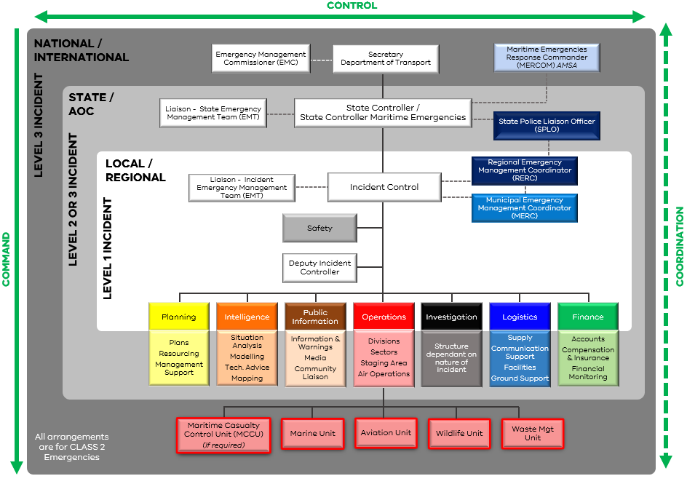

The same key principles of the structures shown in figure 6 are:
- There is a single IC
- The IC remains in overall control and sets the objectives of the incident, however, as the size and/or complexity of each of the hazards involved increases, the IC may delegate certain duties (including independent decision making) to a Deputy IC, to ensure focused oversight of the management strategies and tactics associated with that hazard.
- As the size and/or complexity of each of the hazards involved in the maritime emergency increases, the operations function may be separated out into focused units by hazards or sub-functions such as wildlife and waste management.
- The functions of logistics, planning, intelligence, public information and finance remain as shared functions to minimise duplication and to ensure response efforts are effectively coordinated (for example: one source, one message for public information and warnings).
NB: The vessel master of any vessel/s involved in an incident, remains in command of the vessel and its crew.

3.3.4 Incident levels
The incident level of a maritime emergency will be determined by the actual or possible consequences, the number or nature of the resources required, duration and complexity of response (cargo types and nature of the recovery operations required).
In accordance with AIIMS, and under the National Plan, there are three incident levels for maritime emergencies (NSR). This subplan will utilise the same criteria as the National Plan for categorising incidents as follows:
- Level 1 Incidents are generally able to be resolved through the application of local or initial resources only (e.g. first-strike capacity).
- Level 2 Incidents are more complex in size, duration, resource management and risk, and may require deployment of jurisdiction resources beyond the initial response, requiring state involvement.
- Level 3 Incidents are generally characterised by a degree of complexity that requires the Incident Controller to delegate all incident management functions to focus on strategic leadership and response coordination and may be supported by national and international resources (Refer to section 4.1.2 for more information).
In the event a Level 1 incident escalates beyond first strike capability, the SCME will determine the incident level.
Incident classification by the likely consequences, rather than a set criterion, recognises for example, that the spilling of a set amount of oil in offshore waters, as opposed to same volume spilling in port waters or near the shoreline will have very different consequences and levels of response required.

3.3.5 Deeming of a major emergency
Level 2 and Level 3 maritime emergencies are likely to involve state or national response efforts, these emergencies are likely to meet the definition of a major emergency under the EM Act 2013, requiring notification to the EMC.
A major emergency is a large or complex emergency which:
- has the potential to cause or is causing loss of life and extensive damage to property, infrastructure or the environment; or
- has the potential to have or is having significant adverse consequences for the Victorian community or a part of the Victorian community; or
- requires the involvement of two or more agencies to respond to the emergency;
The SCME is responsible for notifying the EMC should the incident be considered a major emergency.

3.3.6 Consequence management
Under the Emergency Management Act 2013, the EMC has overarching responsibility for strategically managing the consequences of major emergencies. The State Emergency Management Team (SEMT) comprised of senior officials from departments and agencies manages immediate and medium/long term high level impacts of an incident.
Consequences, including the capability and capacity of the control and support agencies to manage them, should be considered in all aspects of maritime emergency planning and preparation.
Maritime emergency consequence planning should take into consideration the following potential impacts:
- social and Aboriginal heritage places impacts
- species and habitat loss
- environmental damage
- tourism impacts
- disruption to marine aquaculture, recreational and commercial fishing operations
- disruption to freight shipping movements and potential supply chain impacts
- disruption to business or infrastructure
- economic loss at local, regional or state levels

3.3.7 Recovery
In Victoria, the EMC is responsible overall for coordinating recovery activities. The EMC does this through the state recovery coordinator and the state relief and recovery team for large or complex emergencies. The SEMP further outlines recovery coordination responsibilities and lead and support agencies.
The recovery process, much like preparing for emergencies, is a shared responsibility between, governments, agencies, non-government organisations and communities. Victoria has a ‘Resilient Recovery Strategy’ which identifies four strategic actions to promote a shared responsibility approach to recovery planning and delivery.
Large or complex maritime emergencies have the potential impact all four of the recovery environments. During any level of maritime incident, planning for recovery of social, built, economic and natural environments should begin as soon as the potential impact of the emergency becomes understood, and should include having dedicated recovery officers as part of IMT and EMT structures.
Where a maritime emergency has significant effect on the natural environment, the recovery should seek to, where viable, restore environmental values lost or damaged through the emergency event and response activities.
Each recovery lead or support agency should have the processes in place to scale up in order to implement appropriate recovery activities within their responsibilities outlined in the SEMP, whether through shared resource arrangements or use of trained volunteers for example. Transition to recovery arrangements are covered in more detail in the operation plan (Part B).
The recovery process after an emergency is often complex and for small incidents may be short (weeks/months), however for large emergencies, recovery can often take many years.

3.4 Control
Control is the overall direction of emergency management activities during an emergency across all agencies. Agencies is defined in the Emergency Management Act 2013 to include all government and non-government agencies.
The ‘line of control’ refers to the line of supervision for those appointed to perform the control function.
Whilst many emergencies utilise incident, regional and state tiers for exercising the necessary control functions at each level, given the complex nature of maritime emergencies, unlike some class 1 emergencies, the Regional Controller is unlikely to be invoked unless there are significant consequences widespread across a region(s) that need to be managed.
The line of control for maritime emergencies in Victoria is from the IC directly to the SCME. This is important given:
- Span of control for maritime emergencies does not see multiple ICs requiring regional control.
- The IC needs to be able to directly seek advice and access to intervention powers from the state or national level through the SCME or the Maritime Emergency Response Commander (MERCOM) that have the powers of intervention and direction.
- There are limited specialists available and a third level may not be able to be resourced appropriately.
The IC has responsibility for setting the incident objectives and overseeing the strategies and tactics at the incident level. The SCME has responsibility for oversighting incident control and ensuring appropriate resources are available to the IC, that the risk and consequence to the State are being appropriately managed. The MERCOM may assume control if requested or required.
The IC may be supported by Deputy ICs and agency commanders in the operations unit from relevant agencies with a functional expertise (e.g. wildlife, oil pollution). See figure 6.
If deemed necessary due the nature and/or size of an incident, the SCME may appoint an Area of Operation Controller (AOC), who’s role is similar to that of the Deputy State Controller (as outlined in the SEMP).

3.4.1 Agency roles and responsibilities
Maritime emergencies may involve multiple, concurrent hazards, involving multiple agencies and requiring several control agencies to operate together. That is, an incident could be one or more of marine pollution, maritime casualty, HNS and/or wildlife affected by marine pollution.
Maritime emergencies are categorised by levels, and control agencies may be determined based on this level (refer to section 3.3.4 Incident Levels).
Consistent with the SEMP and for the purposes of understanding the operation of this subplan, the control agencies for different types of maritime emergencies are outlined in Table 3. The control agency may vary depending on the location (e.g. waterway) of the incident and/or the most significant hazard.

Table 3. Control agencies for different types of maritime emergencies

Emergency Type | Level 1 Incident | Level 2 or 3 Incidents | Class
Marine Search and Rescue | Victoria Police | Victoria Police | Class 2
Hazardous and Noxious Substances (HNS) | CFA/FRV | CFA/FRV | Class 1
Marine Pollution Oil spills in Victorian Coastal waters up to three nautical miles | Port Management Bodies and  Gippsland Ports Committee of Management Inc | DoT | Class 2
Maritime Casualty – non Search and Rescue – Port Waters | Port Management Body /  Local Port Manager | DoT | Class 2
Maritime Casualty – non Search and Rescue – Coastal Waters | Director Transport Safety* | DoT | Class 2
Wildlife affected by marine pollution | DELWP | DELWP | Class 2

*Responsibilities of the Director, Transport Safety are enacted through Transport Safety Victoria (TSV).

3.4.2 Control agency jurisdictions for marine pollution incidents
Each of the port management bodies and Gippsland Ports Committee of Management Inc has been issued a Direction under section 71B of the Marine (Drug, Alcohol and Pollution Control) Act 1988 to assume control and provide an initial (first strike response) for all Level 1 marine pollution incidents within state waters.
Appendix 4 illustrates the jurisdictional boundaries for establishing control agencies and initial response (first strike) for Level 1 marine oil pollution incidents.
DoT will assume control for all Level 2 and 3 marine pollution incidents with the support of the other Level 1 control agencies.

3.4.3 Control Agency jurisdictions for Maritime Casualty Incidents
Port management bodies and local port managers are the control agency for maritime Level 1 casualty incidents within their port waters and are responsible for the initial response. Outside port waters, the Director Transport Safety has been delegated control agency responsibilities for Level 1 casualties, which is enacted through Transport Safety Victoria (TSV). TSV is responsible for the first response outside port waters and may seek support from port management bodies and local port managers with the capabilities to manage the incident.
If there is casualty incident of a size and nature that is beyond the capabilities of the designated control agency, the SCME may appoint an IC. The appointed IC may be from another agency or port manager with appropriate capabilities.
Maritime casualty incidents have the potential to result in or involve marine pollution and where it is initially unclear which body of water the vessel is in, or where there is uncertainty as to the jurisdiction, or where the casualty is within multiple jurisdictions, the marine pollution control agency will assume control and undertake the initial response, until determined otherwise by the SCME.

3.4.4 Control agency jurisdictions for maritime HNS incidents
In Victoria, hazardous materials, high consequence dangerous goods or dangerous goods (including leaks and spills) are a Class 1 emergency for which the control agency is either Fire Rescue Victoria (FRV) or Country Fire Authority (CFA), depending on the region.
Maritime incidents involving hazardous and noxious substance spills, either into state waters or occurring as part of a maritime casualty, will therefore be treated as a Class 1 emergency in the first instance.
When it is determined by the control agency (FRV/CFA) that the HNS no longer poses a threat to the community or to Class 2 agency responders, control may transition to the appropriate class 2 agency to undertake any further necessary response, clean up, or recovery activities.
Control for maritime emergencies HNS, or incidents involving vessel fires (Table 4), is defined under the Country Fire Authority Act 1958 and the Fire Rescue Victoria Act 1958 (formerly known as Metropolitan Fire Brigades Act 1958).
Table 4. Jurisdiction for Level 1, 2 and 3 HNS incidents.
Control Agency | Jurisdiction Level
Country Fire Authority (CFA) | All country areas as per the CFA Act outside the metropolitan area but not including forest, national parks, or Protected Public Land.
Fire Rescue Victoria (FRV) | All areas in the Fire Rescue Victoria Fire District as defined in the FRV Act.

3.4.5 Control agency jurisdictions for marine pollution associated with facilities and commonwealth waters
For facilities operating in commonwealth waters where there is no potential impact on state waters or shorelines, the facility operators will maintain control of the response. However, if the incident has the potential to, or enters state waters, then the relevant control agency for marine pollution will assume control with the facility operator’s involvement.
If a significant offshore incident occurs in an offshore facility or title area involving the actual or potential escape of petroleum, NOPSEMA may declare an ‘Oil Pollution Emergency’ after consultation with the Secretary, DoT and in accordance with section 576B, Division 2A of the Offshore Petroleum and Greenhouse Gas Storage Act 2006.
If the facility or title area is land based or located within state waters, the facility operator will maintain control for Level 1 incidents. Victorian government agencies can provide assistance upon request.
DoT will assume control if the incident is predicted to escalate in size, complexity or to a Level 2 or 3 response. DoT will maintain continual engagement with the facility operator.
Regardless of who is controlling the incident, in all instances the facility owner/operator or titleholder continues to be responsible for clean-up financially (as part of the response and providing resources to the response) as per their oil pollution environment plan and under relevant legislation and polluter pays principles.
Control arrangements for marine pollution originating from facilities or vessels are summarised in Table 5.

Table 5. Facility and vessel control agency arrangements.
Emergency location | Control Agency and Jurisdiction
Vessels outside state waters | AMSA  Vessels outside state waters. This includes Commonwealth waters at Point Wilson, Western Port (HMAS Cerberus) and Gellibrand.  Under the National Plan arrangements, AMSA may request that the state take control if:  - the spill is likely to impact on the Victorian shoreline  - AMSA personnel are in-transit to the location of the incident and/or  - It is more practical to have the state respond on behalf of AMSA.
Maritime facility* within or adjoining state waters | Facility operator  DoT may assume control if the response is escalated.
Offshore petroleum facility** beyond 3 nm | Facility operator  DoT may provide a liaison officer within the Incident Management Team (IMT). DoT will assume incident control for any portion of the spill that enters state waters, with ongoing support from the operator.

*Maritime facility includes but is not limited to a wharf or mooring at which a vessel can be tied up during the process of loading or unloading a cargo (or passengers).
**Offshore petroleum facility means a facility operating in accordance with the provisions of the Offshore Petroleum and Greenhouse Gas Storage Act 2006 or any relevant state legislation. Industry contingency plans should include arrangements for transfer of control to DoT and provision of ongoing support under such circumstances.

3.4.6 Emergency Management Team (EMT)
To ensure EM arrangements are scalable, Victoria has three operational tiers. Each tier has a controller who is supported by an Emergency Management Team (EMT). Refer to the SEMP and the Emergency Management Team Arrangements (Dec) 2014 for detailed descriptions of the functions and membership at each EMT tier.
If an emergency requires a response by more than one agency, the controller at each tier is responsible for convening an appropriate EMT as soon as practical. An EMT can be virtual (e.g. teleconference) or at a location designated by the controller.
Tables 6 and 7 show suggested EMT agency membership for different types of maritime emergencies.
Part B of the subplan further outlines the responsibilities of EMTs at local, regional and state levels for maritime (NSR) emergencies.

Table 6. EMT agency memberships for maritime casualty incidents
Level 1 – vessel and minimal risk of pollution or HNS | Level 2 / 3– vessel and potential risk of pollution or HNS during recovery
Deployed to site or ICC: | Deployed to site or ICC:
- Port Management Body / Local Port Manager  - TSV | - TSV  - Port Management Body / Local Port Manager  - EPA  - DoT  - Fire Service
Notified with potential to deploy to site/ICC: | Notified with potential to deploy to site/ICC:
- DoT  - EPA  - RERC  - MERC  - DELWP (Wildlife)  - AMSA  - Fire Service | - RERC  - MERC  - AMSA Casualty Officer  - DELWP (Wildlife)  - LGA EMLO

Table 7. EMT agency memberships for pollution or HNS incidents
Level 1 – substance on water/land | Level 2 / 3 – substance on water/land
Deployed to site or ICC: | Deployed to site or ICC:
- Control Agency  - Port Management Body / Local Port Manager  - EPA | - Control Agency (DoT)  - EPA  - Port Management Body / Local Port Manager  - DELWP (Wildlife)  - AMSA
Notified with potential to deploy to site/ICC: | Notified with potential to deploy to site/ICC:
- DoT  - AMSA  - FIRE Service  - RERC  - MERC  - DELWP (Wildlife) | - AMSA  - FIRE Service  - RERC  - MERC  - LGA EMLO

State Control Team (SCT)
The State Control Team (SCT) for this subplan will be activated by the State Controller Maritime Emergencies (SCME), in consultation with the EMC, in the event of a possible or actual Level 2 or Level 3 incident.
Table 8 outlines the standing membership of the SCT. Meetings of the SCT may be held in person or virtually.
Table 8. SCT Membership
Incident level | Standing SCT | Other leads as determined by the SCME or EMC – include:
Level 2 | - SCME (Chair)  - EMC  - TSV Director Maritime Safety (or Delegate)  - State Police Liaison Officer  - State Consequence Manager  - State Relief and Recovery Manager  - DELWP State Agency Commander  - EPA – Chief Environmental Scientist (CES) | - DoT Executive Director  - Fire Agency Chief Officer (if HNS or Fire possible/involved)  - DELWP Chief Officer (if wildlife involved)  - DH  - State Health Commander  - EPA
Level 3 | All members of Level 2 plus;  - MERCOM (AMSA)  - DoT Director Resilience and Emergency Coordination  - Fire Agency Chief Officer  - DELWP Chief Officer (or delegate: State Agency Commander) | - DH  - State Health Commander

Incident Management Team (IMT)
Maritime emergencies involve many control agencies, particularly when they are large, complex or involve a range of hazards.
Where there are concurrent hazards within the one incident, guidance in Part B should be used to establish who should lead the control team based on the highest order of hazard risk and consequence.
It is important for the AIIMS principle of unity of command to operate in terms of the IC forming the lead with the support of other agencies who will perform a support (command) function.
In the event of uncertainty or a conflict as to who should lead a Level 1 response, the SCME may determine this based on the hierarchy of risk and consequence and capabilities required of the IC. In the event of a Level 2 or 3 Incident, the SCME will appoint the IC.
Depending on the complexity, deputy ICs may be appointed where the risk and/or span of control necessitates.
It is the responsibility of the Incident Controller to determine the most appropriate IMT structure to put in place, and to form an incident EMT if required.
For Level 1 incidents, beyond the initial assessment phase, if it is determined that deployment of personnel and/or resources is required, the IC should consider delegating operations and public information.
For Level 2 and 3 incidents the IC will delegate each of the IMT functions and agency commanders form part of the control team at the incident tier.
For a large or protracted maritime casualty or pollution response, the operations unit typically includes the following specialist operational functions: aviation, marine, shoreline, wildlife, waste and workplace health and safety. Marine pollution response may also include a dedicated environment function within the intelligence unit and employs specialist environment, scientific and technical advisers at all levels of the IMT.

3.4.7 Appointment of Incident Controllers (IC)
The role of the incident controller (IC) is to provide leadership and management to resolve the emergency and operates in close proximity to the incident.
The IC has responsibility for the overall direction of tactical response and support activities at the incident level. For maritime emergencies, the responsibilities of the IC are consistent with those outlined in the SEMP.
A deputy incident controller is an individual appointed under the same provisions as an IC, usually for Level 2 or 3 incidents. The deputy IC supports the IC in the management of the incident.

For Level 1 incidents, the relevant control agency is responsible for:
- Providing accredited personnel to undertake the role of IC.
- Appointing an appropriately trained IC for a given incident.
For Level 2 and 3 incidents, the SCME will:
- Ensure they appoint accredited personnel to undertake the IC role for Level 2 and 3 incidents, in accordance with the EMV/AMSA accreditation frameworks.
- Appoint the IC and the deputy ICs, which may initially be confirmed verbally and then confirmed by a written instrument of appointment.

3.4.8 Incident Control Point (ICP) and Incident Control Centre (ICC)
For Level 1 Incidents, the IC is responsible for establishing an Incident Control Point (ICP). The ICP could be established on site or in a port office for example. However, if the level of the response escalates then a designated ICC, which can sustain a fully staffed IMT, should be established in proximity to the incident.
Level 2 and 3 Incidents are to be managed through an ICC or Regional Control Centre (RCC) approved by the SCME (standard ICC/RCC footprints are outlined in JSOP 2.03).
The location of the ICP or ICC in use must be clearly identified and communicated to all agencies.

3.4.9 Specialised support services
Any agency that has the skills, expertise or resources that may contribute to the management of a maritime emergency may be requested to assist in emergency response. Table 9 details some Specialist Support Services that are available to assist an IMT with maritime emergencies.
Table 9. Specialist support services
Support Service | Primary Agency | Secondary Agency
Detection of emergency locator transmitters | AMSA | AIRSERVICES AUSTRALIA
Mapping services/information including:  - Digital and hardcopy maps  - Aerial photography acquisition  - GPS positioning and location | DoT  DELWP | GEOSCIENCE AUSTRALIA
Investigation of pollution | EPA

3.4.10 Related emergencies – agencies roles and responsibilities
Maritime emergencies (NSR) may be a result of a land based emergency or result in the requirement for an on-land response that needs to be managed.
A range of agencies have defined control agency responsibilities (see Table 10) and depending on the emergency, a transfer of control to or from a maritime emergency (NSR) may be required. For example, pollution from land that enters state waters may require a joined up approach.
Table 10. Control agencies for related incidents.
Emergency Type | Control Agency  (May vary by location)
Fire and explosion | CFA/FRV
Hazardous materials (all waters) | CFA/FRV
Non-hazardous pollution of inland waters | DELWP
Public transport disruption (water taxis, ferries, etc.) | DoT

3.4.11 Control of incidents that cross control agency boundaries
If a maritime emergency has the potential to cross the boundaries of two control agency jurisdictions, a single IMT may be established, particularly where the incident may be escalated. If the incident is escalated and control is transferred, both affected jurisdictional agencies will continue to provide support and local knowledge throughout the response.
The IC will liaise with Response Support Agency (RSA) Regional Commanders through the Regional Emergency Management Team (REMT) to ensure they are aware of the potential impact/risks in their region, to ensure their preparedness and to prioritise potential resources (especially if multiple incidents are occurring).
DoT will notify statutory authorities from neighbouring jurisdictions if there is potential for the incident to cross boundaries. If applicable, the SCME will also formally contact their counterpart in that jurisdiction to establish communication protocols between the jurisdictions and invite a liaison officer to be part of the IMT.
For incidents which cross state borders, the SCMEs of impacted states will liaise and determine whether there is a need for separate ICC to be established in each state, based on risk assessments of the situation. The primary ICC may be established in the state where the impact is likely to be greatest, with all media communications originating from that centre in consultation with the neighbouring state.
The SCME and the IC, in consultation with the respective states, will determine if an interstate ICC needs to be established. The SCME will notify the EMC of any potential or actual cross-state activity.

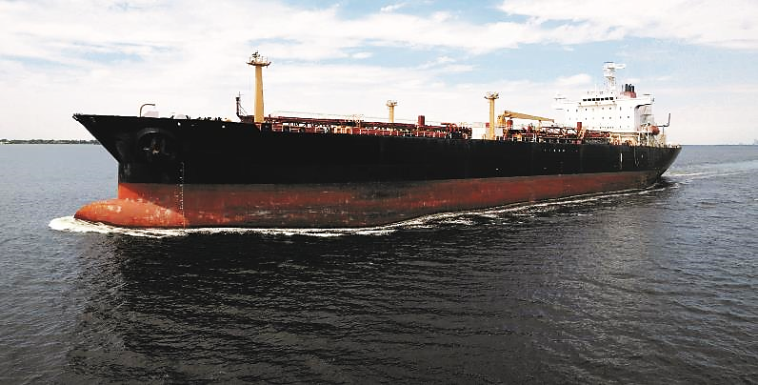

3.5 Communications

3.5.1 Notifications
Control agencies are required to maintain 24 hours a day, 365 days a year capability to receive third party reports of suspected maritime emergency incidents and be able to initiate a response without delay to reported incidents (e.g. first strike response capacity). Agencies must ensure they have capability to conduct an initial assessment in accordance with processes outlined in the Operational Plan (Part B).
If a maritime emergency is considered a major emergency under the EM Act 2013, or an incident is considered significant (e.g. high media interest, sensitive environmental issues) the SCME (or their representative) is responsible for notifying the EMC as outlined in Joint Standard Operating Procedure (JSOP) 3.16 Significant Event Notification.
In the event of a Level 2/3 incident, additional notifications may be required by the SCME to the EMC (Figure 7), the State Control Centre (SCC) and other agencies who may be assisting with the response including neighbouring jurisdictions if the spill is likely to cross shared borders.

Figure 7. Information flow and notification process for maritime casualty and marine pollution incidents
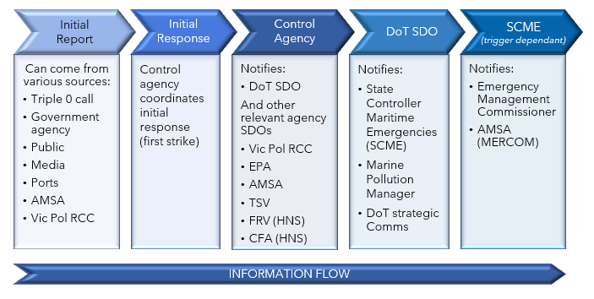

3.5.2 Emergency information and warnings
The IC is responsible for ensuring timely, tailored information is provided to the community.
When a maritime emergency occurs, the IC of the relevant control agency will ensure that public information and warnings (as necessary) are published to the Vic Emergency Website www.emergency.vic.gov.au along with sending warnings to relevant emergency broadcasters.
The Vic Emergency website reports maritime emergencies under four categories depicted by the following icons:
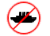
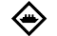

Marine incident Oiled Wildlife Water Pollution Port Closed
Where multiple hazards are presented, but it remains as one incident, the primary hazard will drive the warning type and icon that will be used.
During a major emergency (Level 2 or 3 incident) or where the SCME is activated, they will coordinate whole of government state-level messaging with the respective control agency (FRV, CFA, DoT, DELWP), and in collaboration with the Emergency Management Joint Public Information Committee (EMJPIC).
Emergency information and warnings should be:
- Tailored to include specific details about the emergency and any likely or actual impacts on the community.
- Updated regularly or as the situation changes.
- contain advice on protective or specific actions the community should undertake to remain safe.
- Provided through multiple channels including social media, news, radio, community meetings, newsletter, industry networks or other avenues as required.
Further information on the issuing of public information and warnings is outlined in the operational plan Part B.

3.5.3 Critical information flow during an escalating or major emergency
People involved in the incident, play a critical role in enabling other agencies to support their needs through the provision of information. The importance of rapid, accurate information flow from the incident area upwards is more important than ever before. In addition to providing the critical data for strategic decisions being made regarding resources and incident management, information coming from the incident ground (especially the first arriving resources) is required to determine what advice or warnings need to be communicated to the community.

3.5.4 Common Operating Picture (COP)
The purpose of the Common Operating Picture (COP) is to build and maintain a common situational awareness among all agencies and personnel involved in the response to and resolution of an incident, and to support decision making and planning at all levels.
The COP is built and maintained by the intelligence unit through a collaboration process with all members of the IMT, EMT and other external sources. Where the intelligence unit is not established, the planning unit is responsible for maintenance of the COP.
The tools to be used for establishing a Common Operating Picture may include:
- Emergency Management - Common Operating Picture (EM-COP)
- National Emergency Maritime Operations (NEMO) system
- Situation Reporting (SITREP)
The use and application of these systems is described in the operational plan (Part B).

4 Capability and resource management

4.1 Responsibilities of marine pollution control agencies
Each marine pollution control agency must:
- Ensure a sufficient number of personnel are available, 24 hours a day, 365 days of the year to initiate a response without delay to any report of an actual or suspected Level 1 marine pollution or maritime casualty incident in their prescribed region (refer Appendix 2 and 3) in accordance with this subplan.
- Provide an accredited IC for Level 1 incidents to take control of the incident and to:
  - establish an appropriate incident management and emergency management teams
  - ensure public safety including the issuing of relevant warnings and public information
  - manage response operations in accordance with the systems prescribed in this subplan.
- Work in collaboration with DoT regarding appropriate storage and access of specialist response equipment owned by the State for response to maritime emergencies, in accordance with arrangements detailed in Part B of this Plan.
- Undertake regular readiness checks of specialist equipment and vessels owned and operated by control agencies.
- For marine pollution control agencies, maintain an up to date register as prescribed by DoT, of all material vessels (including vessels of opportunity), property and equipment and other assets in its possession or control, which are capable of being used to support an emergency response.

4.1.1 State Response Team (SRT)
The SRT is comprised of personnel specially trained in various aspects of maritime emergency response. Personnel come from a range of emergency service agencies, local government authorities, and other government departments. DoT coordinates the training of SRT personnel through AMSA, under National Plan arrangements.

4.1.2 National Response Team and Specialist Equipment Caches
On activation of the National Plan, the IC or the SCME may submit a request to AMSA for personnel from other states or the Northern Territory to assist with the incident response, such as in the ICC, IMT or EMT. Suitable personnel will be selected by AMSA from the National Response Team (NRT) or the National Response Support Team (NRST) unless special circumstances exist. AMSA manages a stockpile of specialist response equipment and dispersants at a central location in Melbourne.
The SCME may request national resources through AMSA if:
- the incident has exceeded the state’s capacity to respond;
- the incident requires a resource that can only be obtained nationally; and/or
- the incident is a Level 3 spill requiring immediate escalation.
If national assistance is requested, the EMC must be notified and the control agency is responsible for ensuring that there are appropriate arrangements in place to enable support agencies to be reimbursed for the costs incurred in responding to an incident, consistent with the National Plan. Requests for NRT activation or for specialist equipment should initially be made through the AMSA Joint Rescue Coordination Centre (JRCC) in accordance with the Operational Plan (Part B).
AMSA and individual states and the Northern Territory, can also request assistance from the Australian Marine Oil Spill Centre (AMOSC) and other industry and international resources if required.

Providing assistance to other jurisdictions
Under the National Plan, AMSA can request Victoria’s assistance for maritime casualties and pollution outside Victorian state waters through the SCME. The SCME will consult with the EMC before deploying any Victorian personnel or assets to another jurisdiction.
AMSA may also request that Victoria assumes control of an incident originating from a vessel in commonwealth waters, if:
- the spill is likely to impact the Victorian shoreline;
- AMSA personnel are in transit to the location of the incident; or
- it is more practical to have the state respond on behalf of AMSA.

Victoria may receive a request for assistance directly or via AMSA from an offshore facility operator located in commonwealth waters:
- When a spill is likely to enter state waters.
- When an incident has exceeded the operator’s capacity to respond.
- As per agreed arrangements set out in the operator’s Oil Pollution Emergency Plan.
AMSA’s Coordination of cross-border incidents guidance (NP-GUI-023) provides further details.

4.1.3 International Assistance
AMSA can make arrangements with other countries such as New Zealand and Singapore that have specialist resources and personnel that could support major or complex maritime emergencies.

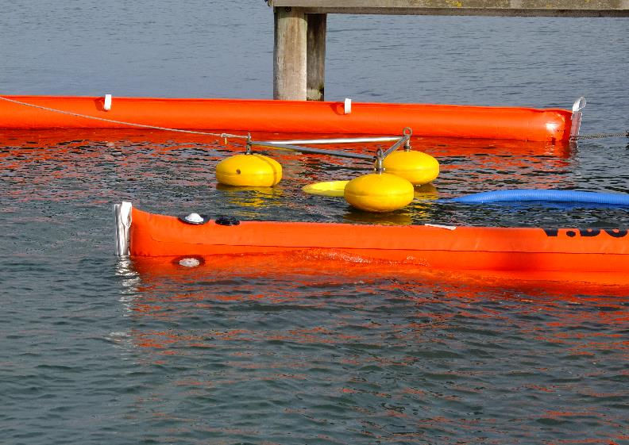

4.2 Capability development

4.2.1 Training standards
Effectively managing a response to a maritime emergency incident requires technical proficiency acquired through training and experience.
State Response Team (SRT) members attend training and exercises in accordance with the SRT training schedule to maintain their skills and maritime casualty and pollution response accreditations. Further information is available in the operational plan Part B.
The training schedule includes accredited courses for Level 1 incidents, including equipment operation, shoreline response, and functional roles within the AIIMS structure. Control agencies and other partner agencies provide training for specialised roles such as HNS, wildlife response, waste management and aerial observation.
Training for Level 2 and 3 incidents can be provided by AMSAs national training program, in accordance with the Australian Qualifications Framework. This includes specialised training for:
- Incident Management Teams
- Logistics Officer
- Operations Officer
- Planning Officer (including Mapping)
- Incident Controller
- Basic Equipment Operator
- Advanced Equipment Operator
- Shoreline Team Leadership
AMSA also delivers an annual specialist workshop for Environmental, Scientific and Technical advisors.
As part of the National Plan arrangements, AMOSC provides oil spill response training for the petroleum industry and is accredited to conduct International Maritime Organisation (IMO) equivalent level I, II and III, Oil Pollution Preparedness, Response and Co-operation (OPRC) training.

4.2.2 Exercising and evaluation
Victoria’s maritime emergency response plans are exercised regularly to:
- Continually assess the efficacy of the arrangements.
- Identify opportunities to improve incident response arrangements.
- Establish and strengthen relationships across relevant response agencies.
- Ensure stakeholders have a thorough and common understanding of:
- command, control, and coordination arrangements;
- roles and responsibilities of stakeholder agencies;
- marine pollution response procedures, issues, and considerations.
The state arrangements will be exercised at least once a year. The exercise will be evaluated and where improvements to the emergency management arrangements in this subplan are identified, the subplan will be reviewed, and a revised version issued. Exercises will be conducted in accordance with the Framework for Managing Exercises in Victoria (available on EMCOP) and the National exercising standard (the Australian Emergency Management Handbook 3 - Managing Exercises 2012, prepared by the Commonwealth Attorney-General’s Department).
Each control agency is required to provide one or more participants that can engage at a state strategic level for an annual state exercise.
National Exercises
State Response Team members will have the opportunity to participate in national exercises coordinated by AMSA on an annual basis.
Control Agency Exercises
To support the arrangements specified in this subplan, each control agency is required to:
- Conduct an internal agency exercise annually, to test their capability related to their area of control.
- Provide trained incident management capability to manage responses to Level 1 incidents within their region and provide support for Level 2 and 3 incidents.
- Participate in state or national exercise opportunities.
- Marine pollution control agencies are required to plan and conduct an annual exercise to test their first‑strike response capability.
  - DoT will support the planning, conducting, observing and evaluation of first strike capability and regional exercises.
  - Exercises should include participation of key support agencies and regional stakeholders.

4.2.3 Operational debriefing
Incident debriefing forms part of the continuous improvement cycle of emergency operations. DoT as the state control agency will organise operational debriefs with participating agencies (including recovery agencies) as soon as practicable after cessation of any response activities that apply to this subplan. Debriefing provides an opportunity to evaluate the adequacy of the response and to recommend changes to plans and procedures to improve future operational response activities.

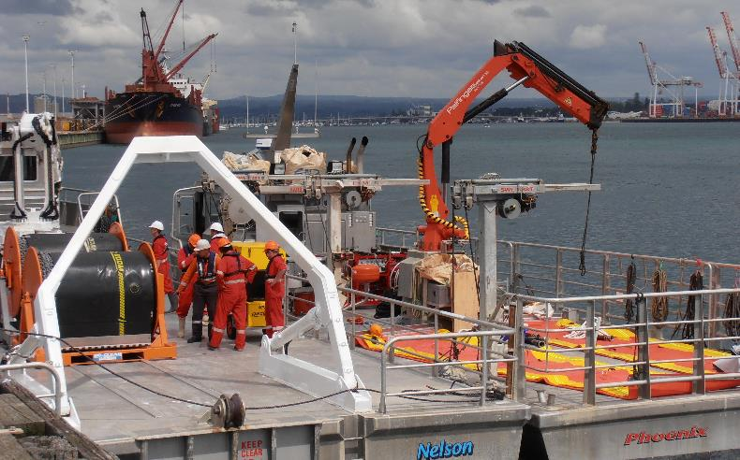

5 Appendices

5.1 Appendix 1 - Authorising legislation

International conventions
Australia is a signatory to two international conventions for preventing and responding to ship-sourced pollution:
- The International Convention on Oil Pollution Preparedness, Response and Cooperation (OPRC) commonly known as OPRC 90), and its associated Hazardous and Noxious Substances Protocol, is the primary international convention for response to ship-sourced marine pollution.
- The International Convention for the Prevention of Pollution from Ships 1973 (MARPOL) (as modified by the Protocol of 1978) is designed to minimise pollution of the seas by oil and other harmful substances from ships and preserve the marine environment.
Relevant national and international protocols, conventions, and arrangements
International Conventions
International Convention on Pollution Preparedness, Response and Cooperation (OPRC) 1990 (IMO)  Related Protocol: Protocol on Preparedness, Response and Cooperation to Pollution Incidents by Hazardous and Noxious Substances 2000, (OPRC-HNS Protocol) | Provides the basis for MENSAR by setting the context for:  - Developing a State system for pollution response  - Maintaining adequate capacity and resources to address oil and HNS incidents  - Facilitating cooperation across all jurisdictions  - Immediate notification of all neighbouring jurisdictions likely to be impacted.
International Convention for the Prevention of Pollution from Ships (MARPOL) 1973 (IMO) | - Provides ships’ construction and operational requirements to prevent pollution from ships.  - Requires ships greater than 400 tonnes gross to have pollution emergency plans.  - Requires mandatory reporting of oil spills.  - Provides for exemptions from discharge restrictions where:  - A discharge is necessary to secure the safety of a ship or to save a life at sea.  - It is necessary during a spill response to minimise the overall damage from pollution and is approved by the relevant government. This includes dispersants.
United Nations Convention on the Law of the Sea 1982 | Article 211 provides general powers for parties to take and enforce measures beyond territorial sea to protect their coastline or related interests from pollution or threat of pollution following a maritime casualty or acts relating to such a casualty that may reasonably result in major harmful consequences.  Article 198 provides that ‘when a State becomes aware of cases in which the marine environment is in imminent danger of being damaged…by pollution, it shall immediately notify other (neighbouring) States it deems likely to be affected by such damage.’
IMO. International Convention Relating to Intervention on the High Seas in Cases of Oil Pollution Casualties 1969  Related Protocol: IFRC Protocol Relating to Intervention on the High Seas in Cases of Pollution by Substances Other than Oil 1973 | This convention provides general powers for parties to take measures on the high seas as may be necessary to prevent, mitigate or eliminate grave and imminent danger to their coastline or related interests from the threat of pollution by oil or hazardous and noxious substances following a maritime casualty or acts related to such a casualty that may reasonably be expected to result in major harmful consequences.
International Convention on Civil Liability for Oil Pollution Damage 1992 | Provides for the recovery of pollution costs and payment of compensation from owners/operators of oil tankers.
International Convention on the Establishment of an International Fund for Compensation for Oil Pollution Damage 1992 | Provides for additional compensation and costs where the tanker owner/operators’ liability limits are exceeded, using funds provided by the oil industry.  Related Protocol: IMO. Protocol of 2003 to the International Convention on the Establishment of an International Fund for Compensation for Oil Pollution Damage, 1992
International Convention on Civil Liability for Bunker Oil Pollution Damage 2001 | Provides for the recovery of pollution costs and payment of compensation from owner/operators of all vessels using oil as bunker fuel.
Guidelines on International Offers of Assistance (IOA) in response to a marine oil pollution incident | Provides guidance on requesting and accepting offers of assistance from other nation states. While these guidelines can play an important role in the implementation of the OPRC 1990 Convention, they are not prescriptive or legally binding, and are meant as a tool to assist as needed.
Resolution A.949 (23) Guidelines on Places of Refuge for Ships in Need of Assistance 2003 and A.950(23) Maritime Assistance Services 2003 | These Resolutions provide guidance on places of refuge for ships and on the provision of a Maritime Assistance Service (MAS) to ships that may need assistance, where the safety of life or rescue of persons is not involved.

National arrangements
Maritime emergency (non-search and rescue) arrangements are supported by intergovernmental agreements and set out in the National Plan.
Through intergovernmental agreements, all jurisdictions have undertaken to provide a response capability within their own jurisdiction and share resources with other jurisdictions. The Commonwealth, through the Australian Maritime Safety Authority (AMSA) coordinates National Plan arrangements.
The National Plan provides a single comprehensive and integrated response arrangement to minimise environmental impacts arising from maritime environmental emergencies.
The national arrangements do not override state legislation, except for specific provisions relating to a maritime casualty that poses a threat of significant pollution.
Relevant commonwealth legislation
Commonwealth Legislation
Australian Maritime Safety Authority Act 1990 | Provides that a function of AMSA is to combat pollution in the marine environment, including provision of services to the states and territories.
Protection of the Sea (Prevention of Pollution from Ships) Act 1983 | Provides exemptions for the discharge of materials in response to marine pollution incidents. This includes the application of dispersants.  Requires ships greater than 400 tonnes gross to have pollution emergency plans.  Provides for emergency discharges from ships.
Offshore Petroleum and Greenhouse Gas Storage Act 2006 | Sets out the requirements for the offshore petroleum exploration and production sector.  Part 6.2 provides for the National Offshore Petroleum Safety and Environmental Management Authority (NOPSEMA) or the Commonwealth Minister to direct the polluter to take actions in response to an incident and to clean up, monitor impacts and reimburse NOPSEMA or the Commonwealth.
Environment Protection and Biodiversity Act 1999 | Regulates activities impacting on defined “matters of national environmental significance”, Commonwealth marine reserves, and species listed under the Act.  Provides for the making of exemptions if in the national interest. An exemption has been issued for activities done pursuant to the National Plan.
Protection of the Sea (Civil Liability for Bunker Oil Pollution Damage) Act 2008 | Places liability on the shipowner(s) for pollution damage caused by loss of bunker fuel.  Provides immunity from legal action for response personnel.
Protection of the Sea (Civil Liability) Act 1981 | Places liability on the shipowner(s) for pollution damage caused by loss of persistent oil from an oil tanker.
Protection of the Sea (Oil Compensation Fund) Act 1993 | Provides additional compensation for pollution damage caused by loss of persistent oil from an oil tanker.
Protection of the Sea (Powers of Intervention) Act 1981 | Provides for intervention powers being exercised in Australia’s EEZ, Territorial Sea and internal waters.
Fisheries Management Act 1991 | Provides regulatory and other mechanisms to support any necessary fisheries management decisions during a response in Commonwealth waters.

Victorian legislation
Victorian Legislation
Emergency Management Legislation Amendment Act 2018 | Provides for new integrated arrangements for emergency management planning in Victoria at the State, regional and municipal levels.
Emergency Management Act 1986 | Provides for integrated and comprehensive prevention, response, and recovery planning, involving preparedness, operational co-ordination, and community participation, in relation to all hazards.
Emergency Management Act 2013 | Provides for the establishment of governance arrangements for emergency management in Victoria, including the Office of the Emergency Management Commissioner and an Inspector-General for Emergency Management.
Marine (Drug, Alcohol and Pollution Control) Act 1988 (Marine Act) | Defines prohibited discharges.  Defines the powers of DoT regarding oil pollution response and preparedness.  Allocates roles and responsibilities to ensure there is a capacity and obligation to respond to marine incidents that have the potential to result in pollution.  Section 71A sets out functions to ensure adequate means exist to respond to marine pollution in Port and State waters.
Marine Safety Act 2010 | Provides for safe marine operations within Victoria by setting licensing and operational requirements.  Provides powers to police to enforce the safety of vessel operators and to Office of the Director Transport Safety staff to enforce vessel safety.  Also gives police powers to check vessel owners/operators.
Environment Protection Act 2017 | Provides the foundation for a transformation of Victoria’s environment protection laws and Environment Protection Authority Victoria (EPA).  The general environmental duty (GED) is at the centre of the Environment Protection Act 2017 and it applies to all Victorians, who must reduce the risk of harm to human health and the environment from their individual or business activities.  The Act focuses on preventing waste and pollution, rather than managing impacts after they occur. The GED is criminally enforceable.
Pollution of Waters by Oil and Noxious Substances Act (POWBONS) 1986 | POWBONS and POWBONS Regulations 2012 make provisions for the protection of the sea and certain waters from pollution by oil and other noxious substances and implement the International Convention for the Prevention of Pollution from Ships (1973).  Prohibits discharge of oil, oily mixtures, and other materials.  Implements Annex 1 of the MARPOL Convention.  Requires mandatory reporting of marine pollution incidents.
Offshore Petroleum and Greenhouse Gas Storage Act 2010 | Sets out the requirements for the offshore petroleum exploration and production sector in Victorian offshore waters.
Flora and Fauna Guarantee Act 1988 | Provides for the conservation and biodiversity of Victoria’s native flora and fauna, including the management of potentially threatening processes.
Wildlife Act 1975 | Provides for the protection and conservation of wildlife.
Fisheries Act 1995 | Provides for the regulation, management and conservation of Victorian fisheries (both commercial and recreational), including aquatic habitats.
Wildlife (Marine Mammals) Regulations 2009 | Provides for the long-term protection of marine mammals.
Local Government Act 1989 | Provides a framework for the operation of local councils.  Provision in local plans for prevention, preparation for, response to and recovery from emergency incidents, including:  - Management of local infrastructure and community assets.  - Liaison with local communities and business networks.  - Enforcement of relevant local laws, such as access control, parking, safety, pets.
Local Government Act 2020 | The Local Government Act 2020 is a principles-based Act, removing unnecessary regulatory and legislative prescriptions outlined in the previous 1989 Act. The Act provides under section 87 for the Minister for Local Government to issue Ministerial Good Practice Guidelines (MGPGs).
Port Management Act 1995 | Provides for the establishment, management and operation of commercial trading ports and local ports in Victoria and the preparation of Safety Management Plans and an Environment Management Plans (together known as Port Safety & Environmental Management Plans (PortSEMPs) and  Part 5B refers to hazardous or polluting activities.
Aboriginal Heritage Act 2006 | Provides for the protection of Aboriginal Heritage Places in Victoria.
Heritage Act 1995 | Provides for the protection and conservation of Aboriginal Heritage Places and objects of heritage significance.
Marine and Coastal Act 2018 | The Marine and Coastal Act 2018 provides a simpler, more integrated and coordinated approach to planning and managing the marine and coastal environment by enabling protection of the coastline and the ability to address the long-term challenges of climate change, population growth and ageing coastal structures.

5.2 Appendix 2 - Victoria’s commercial trading ports

Ports Victoria, established on 1 July 2021 have overarching responsibility
for the channels and port waters of Victoria’s commercial ports.

Victoria has four commercial trading ports profiled below:

- Port of Melbourne is Australasia’s largest maritime hub for containerised, automotive and general cargo. It is a key economic asset for businesses and people across Victoria and south-eastern Australia. The Port of Melbourne welcomes over 7500 vessel movements annually and comprises of 100,000 hectares of port waters, 21 kilometres of waterfront and 36 commercial berths.
- Port of Geelong is Victoria’s second largest port, handling over $7 billion of trade and more than 1000 vessel visits each year. The Ports exports consist mainly of raw materials, including petroleum products, bulk and bagged grain and woodchips, while the majority of imports are crude oil, petroleum products and fertiliser raw material. While Geelong Port manages wharf and land-side infrastructure, Ports Victoria is responsible for channel management and commercial navigation of commercial waters in and around Geelong.
- Port of Hastings is a commercial port, handling approximately 2 million tonnes of trade each year, and servicing major international and domestic shipping movements that include import and export of oil, Liquefied Petroleum Gas (LPG), Unleaded Petroleum (ULP), steel, general and project cargo. The Port of Hastings Development Authority (PoHDA), as Port Operator is responsible for managing the operations at the Port of Hastings, including maintaining the associated port infrastructure (except for the BlueScope owned steel wharves). The channels are managed by Ports Victoria.
- Port of Portland is a deep water port servicing the forest production area of Victoria and South Australia known as the Green Triangle Region. The Green Triangle is centered on Portland, Mt Gambier and beyond. The port has six commercial berths and handles over 7 million tonnes of trade and welcomes more than 300 vessel visits annually. Its main commodities are grain, forestry products including woodchips, aluminium, alumina, liquid pitch, fertiliser and mineral sands.

* Following an independent review of the Victorian Ports sector, from 1 July 2021 the Victorian Ports Corporation (Melbourne) (VPCM) and Victorian Regional Channels Authority (VRCA) came together to form a new entity known as ‘Ports Victoria’. The independent ports review and a new Victorian Ports Strategy (in development), may impact the control and response responsibilities outlined in the subplan in the future.

5.3 Appendix 3 - Victoria’s local ports

Location of local ports (correlating table numbers show management responsibility)
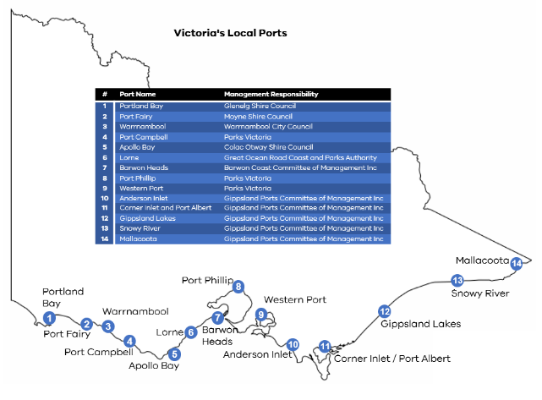

5.4 Appendix 4 - Jurisdictional boundaries and maps
Victoria’s Control Agency boundaries for first response/Level 1 Marine Pollution Incidents are outlined in the table below.

Victoria’s control agency boundaries for first response/Level 1 marine pollution incidents.
Region | West Boundary | East Boundary | Includes | Regional Control Agency (RCA)
Portland | SA Border | Cape Otway | Enclosed waters. | Port of Portland Ltd
Port Phillip | Cape Otway | Cape Schanck | Port Phillip Bay, enclosed waters and upstream, where pollution is sourced from port waters. For Yarra and Maribyrnong Rivers, includes waters downstream of the Bolte and Shepherd Bridge. | Ports Victoria
Docklands | Charles Grimes Bridge | Bolte Bridge | Docklands includes waters upstream of the Bolte Bridge and downstream of the Charles Grimes Bridge. | Department of Transport
Western Port | Cape Schanck | South-east point of Wilson’s Promontory | Western Port and enclosed waters. | Ports Victoria
Gippsland | South-east point of Wilson’s Promontory | NSW Border | Corner Inlet and enclosed waters. | Gippsland Ports Committee of Management Inc

A visual representation of Control Agency jurisdictional support boundaries for First Response/Level 1 Marine Pollution Incidents within Victoria.
Support boundaries for Level 1 marine pollution responses
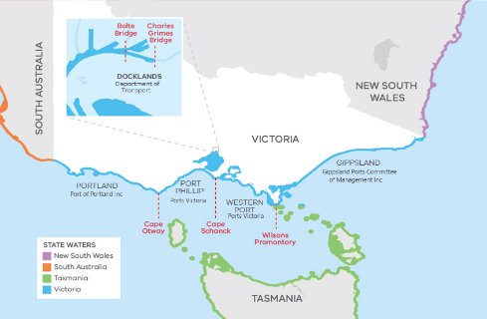
FRV and CFA/Coast Guard have different jurisdictional boundaries for HNS response which is outlined below.
FRV and CFA (including Coast Guard) HNS marine jurisdictions.
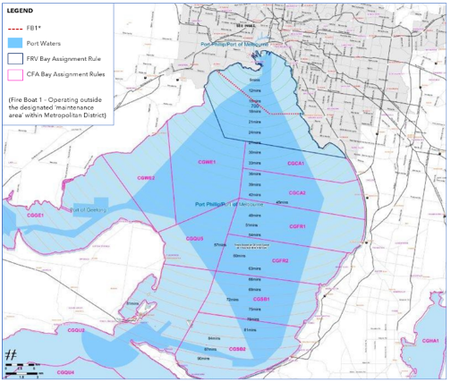

5.5 Appendix 5 - Glossary
TERM | DESCRIPTION
Agency | A government or non-government agency
AMOS Plan | As per the National Plan  A plan managed by Australian Marine Oil Spill Centre (AMOSC) and outlines the cooperative arrangements for response to oil spills by Australian oil and associated industries.
Bunker | As per the National Plan  a heavy fuel oil, intermediate fuel oil, blended distillate or diesel used as a vessel’s fuel.
Bunkering operations | Means the transfer between a vessel and a barge, other vessel or road tanker, including all activities preparatory and incidental to the transfer, of the following:  - Flammable and combustible fuel for main propulsion and auxiliary operations  - Lubricating and hydraulic oil for machinery  - Waste oils, sludge and residues  - Slops and tank washings  - Grey water and sewage
Class 1  Emergency | As per Emergency Management Act 2013 section 3  (a) a major fire; or  (b) any other major emergency for which the Metropolitan Fire and Emergency Services board, the Country Fire Authority or the Victorian State Emergency Service Authority is the control agency under the State Emergency Response plan.
Class 2  Emergency | As per Emergency Management Act 2013 section 3  A major emergency which is not –  (a) A class 1 emergency; or  (b) A warlike act or act of terrorism, whether directed at Victoria or a part of Victoria or at any other State or territory of the Commonwealth: or  (c) A hi-jack, siege or riot  (relates to major emergency of pollution/maritime casualty and H&NS)
Chemical terminal | As per the National Plan  a chemical refiner and/or chemical storage/distribution facilities with access to a maritime facility, but not including the maritime facility.
Command | As per the National Plan  the internal direction of the members and resources of an agency in performance of the organisation’s roles and tasks. Command operates vertically within an organisation.
Commonwealth waters | all waters in the territorial sea and EEZ seaward of 3 nautical miles from Australia’s baselines.
Community | As per the National Plan  a group with a commonality of association and generally defined by location, shared experience or function
Control | As per the National Plan  the overall direction of emergency management activities during an emergency event. Authority for control is established in legislation or administratively and carries with it the responsibility for tasking organisations in accordance with the needs of the situation.
Control Agency | the agency or company assigned by legislation (Emergency Management Act 2013), administrative arrangements or within the relevant contingency plan, to control response activities to a maritime environmental plan. The Control Agency will have responsibility for appointing the IC. This is the equivalent of Responsible Agency or Control Authority under AIIMS.
Coordination | As per the National Plan  means the bringing together of organisations and other resources to support an emergency management response.
Emergency | As per Emergency Management Act section 2  an event, actual or imminent, which endangers or threatens to endanger life, property or the environment, and which requires a significant and coordinated response. The term emergency and disaster are used interchangeably within the Australian Emergency Management Arrangements.
Environment | As per the National Plan  the complex of physical, chemical and biological agents and factors which may impact on a person or a community, and may also include social, physical and built elements, which surround and interact with a community.
First Strike  Same meaning as Level 1 | As per the National Plan  a prompt initial response to protect the environment that is intended to limit the effect of an incident until such time as other resources can be deployed in support. This capability may vary from location to location.
Habitat | As per the National Plan  the natural home or environment of an animal, plant or other organism.
Harbour Master | As per the Marine Safety Act section 3  includes an Assistant Harbour Master, authorised under Section 220 and 229 of the Marine Safety Act.
Hazardous and noxious substance | As per the National Plan  any substance which, if introduced into the marine environment, is likely to create hazards to human health, to harm living resources and marine life, to damage amenities or to interfere with other legitimate uses of the sea.
Incident | As per the National Plan  An event, occurrence or set of circumstances that:  - Has a definite spatial extent.  - Has a definite duration.  - Calls for human intervention.  - Has a set of concluding conditions that can be defined.  - Is or will be under the control of an IC appointed to make decisions to control and coordinate the approach, means and actions taken to resolve the incident.
Incident Controller | As per the National Plan  the individual responsible for the management of all incident control activities across an incident.
Incident Management Team | As per the National Plan  The group of incident management personnel comprised of the Incident Controller and personnel appointed by the Incident Controller to be responsible for the overall control of the response to an incident.
Industry | As per the National Plan  Unless already specified or defined in a particular context, means a business or commercial group or sector, or other socially valuable activity, such as fisheries, tourism, infrastructure, transport etc. and their representative groups.
Incident Reports | Situation reports, Pollution reports and Agency reports required under the operational plan.
Internal waters | As per the National Plan  those waters that fall within the constitutional boundaries of the State. The waters which are capable of falling within these limits are described in s.14 of the Seas and Submerged Lands Act 1973 as ‘bays, gulfs, estuaries, rivers, creeks, inlets, ports or harbours which were, on 1 January 1901, within the limits of the States and remain within the limits of the States’.
Local port | means a port declared to be a local port by Order in Council under section 6 of the Port Management Act 1995.
Local port manager | For the purposes of this subplan ‘local port manager’ refers to the organisations with local port management responsibility outlined in Appendix 3.
Marine pollution | As per the National Plan  Refers to any occurrence or series of events with the same origin, including fire and explosion, which results or may result in discharge, release or emission of oil or a hazardous and noxious substance, which poses or may pose a threat to the marine environment, the coastline, animals or other resource, and which requires an emergency action or immediate response.  Under this plan, marine pollution refers primarily to situations that may arise from shore based oil and chemical transfer facilities, shipping operations and/or the operation of an offshore petroleum facility.
Maritime casualty | As per the National Plan  a collision of vessels, stranding or other incident of navigation, or other occurrence on board a vessel or external to it resulting in material damage or imminent threat of material damage to a vessel or cargo.
Maritime emergency | Potential and actual pollution of the sea or harm to the marine environment by oil or hazardous and noxious substance, originating from:  - Maritime casualties requiring salvage and intervention, emergency towage and requests for a place of refuge.  - Oil pollution or hazardous and noxious substance pollution incidents from vessels, oil or chemical terminals and offshore petroleum activities.  - Marine pollution from floating or sunken containers of hazardous materials, or from unknown sources.  - Debris originating from a maritime casualty, or physical damage caused by vessels.
Maritime facility | As per the National Plan  a wharf or mooring at which a vessel can be tied up during the process of loading or unloading a cargo (or passengers). A maritime berth may be a sole user berth (such as a dedicated berth for an oil refinery) or may be a multi user berth, such as a berth that handles general cargo, or one that handles bulk liquids such as petroleum for more than one user of the berth (sometimes known as a common-user berth).
Offshore petroleum facility | As per the National Plan  a facility operating in accordance with the provisions of the Offshore Petroleum and Greenhouse Gas Storage Act 2006, or any relevant State/Northern Territory legislation.
Offshore Petroleum Incident Coordination Framework | outlines the governance arrangements for the Offshore Petroleum Incident Coordination Committee (OPICC), including its purpose, membership and key protocols for member agencies. The OPICC is convened and chaired by the Department of Industry, Innovation and Science. The purpose of the OPICC is to effectively coordinate Australian Government efforts and resources and communicate to the public and affected stakeholders all matters relevant to a significant offshore petroleum incident in Commonwealth waters.
Oil | As per the Pollution of Waters by Oils and Noxious Substances Act, oil and oily mixture have the same meanings as in Annex I to the Convention  As per the National Plan  hydrocarbons in any liquid form including crude oil, fuel oil, sludge, oil refuse, refined products and condensates.
Oil terminal | As per the National Plan  a petroleum refinery and/or petroleum storage/distribution facility with access to a maritime facility, but not including the maritime facility.
Petroleum | As per the National Plan  includes oil and other substances extracted in the recovery of such substances, including LNG and LPG.
Pilot | As per Marine Safety Act  a person who does not belong to, but has the conduct of, a vessel.
Place of refuge | As per the National Plan  a place where a ship in need of assistance can take action to enable it to stabilise its condition and reduce hazards to navigation, and to protect human life and the environment.
Port | As per Marine (Drug, Alcohol and Pollution Control) Act Part 1, includes any of the following waters, or any part of those waters:  (a) any harbour or haven, whether natural or artificial;  (b) any estuary, channel, river, creek or roadstead;  (c) any navigable water in which vessels may lie for shelter or for the transfer of  cargo or passengers;
Ports Victoria | Established on 1 July 2021 following an independent review of the Victorian Ports sector. Ports Victoria brought together the former Victorian Ports Corporation (Melbourne) (VPCM) and Victorian Regional Channels Authority (VRCA).
Port Management Body | As per Marine (Drug, Alcohol and Pollution Control) Act Part 1, port management body means -  (a) in relation to the port of Melbourne, Victorian Ports Corporation  (Melbourne);  (b) in relation to –  (i) the waters declared under section 5 of the Port Management Act 1995 to be the port of Geelong, the Victorian Regional Channels Authority, or, if there is an agreement with a channel operator in relation to those waters, that channel operator;  (ii) the waters declared under section 5 of the Port Management Act 1995 to be the port of Portland, the Victorian Regional Channels Authority, or, if there is an agreement with a channel operator in relation to those waters, that channel operator;  (iii) port of Hastings waters, the Victorian Regional Channels Authority, or, if there is an agreement with a channel operator in relation to those waters, that channel operator.
Protection of the Sea Levy | As per the National Plan  Is a statutory charge against ships, based on the ‘potential polluter pays’ principle and is used to fund the National Plan for Maritime Environmental Emergencies. Funds are also used to meet clean-up costs, which cannot be attributed to a known polluter.
Prohibited Discharge | As per Marine (Drug, Alcohol and Pollution Control Act Section 34  a discharge into State waters of—  (a) oil; or  (b) an oily mixture; or  (c) an undesirable substance;
Recovery | As per the Emergency Management Act section 3  The assisting of persons and communities affected by emergencies to achieve a proper and effective level of functioning.
Responsible Agency | As per the National Plan  See Control Agency
Responsible Party | As per the National Plan  Means the entity that has been identified as owning or having the legal responsibility for the vessel or facility that caused the incident.
Response Agency | Any agency with a role or responsibilities during an emergency response as defined in the Emergency Management Manual Part 7, whether the control agency or a support agency.
Section | As per the National Plan  means the organisational level having responsibility for the key top level functions of incident management: planning, public information, logistics and operations.
SOLAS | As per the National Plan  Safety of Life at Sea – derived from the international convention for the Safety of Life at Sea.
State | As per the National Plan  means, depending on context, one or more of the states or territories of Australia.
State Response Controller | As per the Emergency Management Act 2013 section 37
State waters | As per Marine (Drug, Alcohol and Pollution Control) Act 1988 section 2  - the territorial sea adjacent to the State; and  - the sea on the landward side of the territorial sea adjacent to the State that is not within the limits of the State; and  - waters within the limits of the State.
Support Agency | As per the National Plan  Means an agency or company that provides essential services, personnel, material or advice in support of the Control Agency during the response to a maritime environmental emergency.
Terminal | As per the National Plan  (see also oil terminal and chemical terminal).
Unit | As per the National Plan  means a small cell of people working within one of the sections undertaking a designated set of activities.
Undesirable Substances | As per the Pollution of Waters by Oils and Noxious Substances Act Part 2  (a) any solid ballast, rubbish, gravel, earth, stone or wreck; or  (b) any dangerous, flammable, corrosive or offensive substance, whether solid, liquid or gaseous; or  (c) any article or thing or any substance (whether solid, liquid or gaseous) which is capable of constituting a hazard to navigation or of preventing or hindering the proper use of State waters — but does not include oil or an oily mixture.
Vessel (and /or ship) | - As per the Marine Safety Act section 3 -  any kind of vessel that is used, or capable of being used, in navigation by water, however propelled or moved, and includes—  (a) a barge, lighter, floating restaurant or other floating vessel; and  (b) an air-cushion vehicle, or other similar craft, that is used in navigation by water; and  (c) any aeroplane that is designed for and capable of being waterborne, for so long as that aeroplane is waterborne; and  (d) a life boat; and  (e) a thing being towed by a vessel; and  (f) an off-shore industry mobile unit within the meaning of the Commonwealth Navigation Act—but does not include an off-shore industry mobile unit that is not self-propelled.  - has several meanings within Australian legislation and international conventions, but for the purpose of this Plan means a vessel of any type whatsoever operating in the maritime environment, and includes hydrofoil boats, air cushion vehicles, submersibles and floating craft of any type.  - Throughout this document the term vessel is preferred. Ship, ship-owner and shipping are used where these make sense in context or arise from an official or formal source.

5.6 Appendix 6 - Acronyms
AIIMS | Australasian Inter-service Incident Management System
AMOSC | Australian Marine Oil Spill Centre
AMSA | Australian Maritime Safety Authority
AtoN | Aids to Navigation
CAOiC | Control Agency Officer in Charge
CERA | Community Emergency Risk Assessment
CFA | Country Fire Authority
COAG | Coalition of Australian Governments
DELWP | Department of Environment, Land, Water and Planning
DH | Department of Health (formerly DHHS)
DoT | Department of Transport
EMC | Emergency Management Commissioner
EMCOP | Emergency Management Common Operation Picture
EMJPIC | Emergency Management Joint Public Information Committee
EMMV | Emergency Management Manual Victoria
EMT | Emergency Management Team
EPA | Environment Protection Authority Victoria
ERR | Earth Resources Regulation
FRV | Fire Rescue Victoria
GARS | Greater Alarm Response System
GED | General Environmental Duty
HNS | Hazardous and Noxious Substance
IC | Incident Controller
ICC | Incident Control Centre
IGA | Intergovernmental Agreement
IEMT | Incident Emergency Management Team
IMO | International Maritime Organisation
IMT | Incident Management Team
ISO container | International Standard Organisation container generally for storing liquids
JSOP | Joint Standard Operating Procedure
MCCU | Maritime Casualty Control Unit
MCO | Maritime Casualty Officer
MENSAR | The Maritime Emergencies (Non-Search and Rescue) Plan
MERC | Municipal Emergency Response Coordinator
MERCOM | Maritime Emergency Response Commander
MSV | Maritime Safety Victoria
National Plan | the National Plan for Maritime Environmental Emergencies, and all policy, guidance and advisory documents produced and published in support.
NEBA | Net Environmental Benefit Analysis (replaced by SIMA)
NEMO | National Emergency Maritime Operations
NOPSEMA | National Offshore Petroleum Safety and Environmental Management Authority
NSDR | National Strategy for Disaster Resilience
NSR | Non Search and Rescue
NRST | National Response Support Team
NRT | National Response Team
OSCA | Oil Spill Control Agents
OPEP | Oil Pollution Emergency Plan
POLREP | Pollution notification Report
PortSEMP | Port Safety and Environment Management Plan
PV | Parks Victoria
RCT | Regional Control Team
REMT | Regional Emergency Management Team
REMPC | Regional Emergency Management Planning Committee
RERC | Regional Emergency Response Coordinator (VicPol)
RMERG | Regional Maritime Emergency Reference Group
RSA | Response Support Agency
SCC | State Control Centre
SCME | State Controller Maritime Emergencies
SCRC | State Crisis and Resilience Council
SCT | State Control Team
SDO | State Duty Officer
SEMT | State Emergency Management Team
SEMP | State Emergency Management Plan
SIMA | Spill Impact Mitigation Assessment
SITREP | Situation Report
SMEWG | State Maritime Emergencies (Non-Search and Rescue) Working Group
SPLO | State Police Liaison Officer
SRT | State Response Team
TSV | Transport Safety Victoria
VESTRG | Victorian Maritime Emergency Environment, Scientific and Technical Reference Group
VPCM | Victorian Ports Corporation (Melbourne)
VRCA | Victorian Regional Channels Authority
VTS | Vessel Traffic Service

Australian Sea Freight 2016-17, BITRE 2019
Australian Maritime Safety Authority Domestic Commercial Vessel Annual Incident Report, January – December 2019
Australian Maritime Safety Authority Regulated Australian and Foreign Flagged Vessels Annual Overview of Marine Incidents 2019
Data compiled from MSV/TSV annual reports on maritime safety incident statistics
AMSA – Major historical incidents data
‘Characterization of Low Sulfur Fuel Oils (LSFO) – A new generation of marine fuel oils’ SINTEF Ocean AS/ITOPF
Based on Victorian Marine Risk Assessment 2011
Chapter 7 - Marine and Coastal Policy (marineandcoasts.vic.gov.au)
SEMP– Roles and Responsibilities

