Victoria’s Critical Infrastructure All Sectors Resilience Report 2020

Publication information
Acknowledgement of Country
Emergency Management Victoria acknowledges the Traditional Owners of the land of Victoria and pays respect to their Elders, both past and present.
Authorised and published by the Victorian Government, 1 Treasury Place, Melbourne.
© State of Victoria 2021
This report is protected by copyright. Apart from any use permitted under the Copyright Act 1968, and those explicitly granted below, all other rights are reserved.
ISSN 2207-2020 (Print)
ISSN 2207-2039 (Online)
Published month: February 2021
This document is available in PDF and accessible format at emv.vic.gov.au
You are free to re-use this work under a Creative Commons Attribution 4.0 licence, provided you credit the State of Victoria (Emergency Management Victoria) as author, indicate if changes were made and comply with the other licence terms. The licence does not apply to any images, photographs or branding, including Government logos.
Design, layout and editing by DJCS Creative Services / Strategic Communications.

Contents
1. Ministerial foreword 4
2. Executive summary 5
3. Critical infrastructure in Victoria 6
4. The Victorian Critical Infrastructure Framework 7
4.1 The Victorian Critical Infrastructure Model 8
5. Victoria’s Sector Resilience Networks 9
6. The changing risk environment 11
7. The year in review 13
7.1 Victorians faced multiple emergency events in 2019-20 13
7.2 Emergency events impacting Victorian critical infrastructure 15
7.3 How owners and operators responded to the 2019-20 Victorian bushfires and coronavirus (COVID-19) pandemic 17
7.3.1 2019-20 Victorian bushfires 17
7.3.2 The coronavirus (COVID-19) pandemic 21
8. Looking forward 24
8.1 Priorities for 2020-21 and beyond 24
8.2 Shared emergency risks for sectors in 2020-21 24
8.3 Critical infrastructure interdependencies 24
9. Victoria’s critical infrastructure sectors 27
9.1 Banking and Finance 27
9.2 Communications 30
9.3 Energy 33
9.4 Food and Grocery 36
9.5 Government 39
9.6 Health 41
9.7 Transport 44
9.8 Water 47
10. Conclusion 50

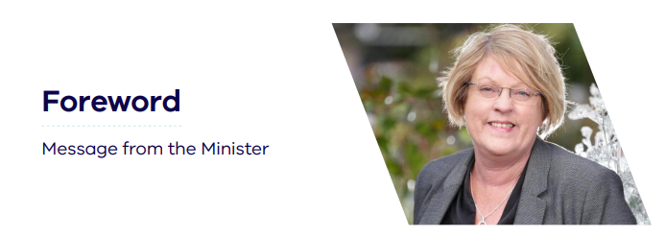
Ministerial foreword
As the Minister for Police and Emergency Services, I am delighted to present Victoria’s Critical Infrastructure All Sectors Resilience Report 2020.
Critical infrastructure provides essential services to the Victorian community for our social and economic wellbeing. Access to water, food and groceries, health services, energy, transport, communications, banking and finance, and government services would not be possible without the infrastructure that supports them.
This report provides an overview of Victoria’s eight critical infrastructure sectors, and the measures undertaken to enhance their resilience.
We have seen the significant impact that large-scale emergencies can have on our economy, essential services, workforces and communities. This year, Victoria experienced its most devastating bushfire season in over a decade, followed closely by the global coronavirus (COVID-19) pandemic. Our experiences over the last 12 months highlight the importance of resilient critical infrastructure, ongoing preparedness by owners and operators, and continued collaboration between industry and government.
Victoria has sophisticated arrangements in place for critical infrastructure resilience. These build on the good work of individual owners and operators and bring groups together to share understanding about key emergency risks and opportunities to build resilience.
I would like to sincerely thank and acknowledge critical infrastructure owners and operators in Victoria for their continued service delivery and unwavering commitment to working together during emergencies in 2019-20, to minimise impacts to the community.

The Hon. Lisa Neville MP
Minister for Police and Emergency Services

Executive summary
Each day, Victorians rely on the continuity of services provided by critical infrastructure owners and operators.
These services, and the infrastructure that supports them, are essential to our health, safety, economy and way of life. The community is significantly impacted if services are degraded or disrupted for a prolonged period. Because not all emergencies can be prevented, owners and operators work with government to improve the resilience and preparedness of Victoria’s critical infrastructure.
Recognising that most of Victoria’s critical infrastructure is privately owned, in July 2015 the government introduced arrangements to enhance its resilience. These arrangements – set out by Victoria’s Critical Infrastructure Resilience Strategy – are founded on collaboration and provide assurance to the public and government that key emergency risks are considered and, where possible, minimised by owners and operators.
This is the fifth All Sectors Resilience Report published under the arrangements. It provides an overview of the eight Victorian critical infrastructure sectors and summarises the impact of emergencies on their services and the community. The report includes resilience improvement initiatives conducted by each of the sectors from mid-2019 to mid-2020 and describes intended initiatives for the next 12 months.
The 2019-20 Victorian bushfires and coronavirus (COVID-19) pandemic highlight the importance of the services critical infrastructure provide to the community and the strengths of the Victorian arrangements.
The high level of goodwill and commitment by all who work in critical infrastructure – and their resilience and adaptability – has been evident during the significant and unprecedented emergencies in 2019-20. Both emergencies show the importance of building trusted relationships in advance. Victoria’s critical infrastructure sectors continue to work with government and emergency services for the benefit of the community.
Resilient critical infrastructure is increasingly important in our constantly changing world. Victorians continue to benefit from these arrangements, which during the significant emergencies in 2019-20 provided a solid foundation for trusted collaboration and shared responsibility.

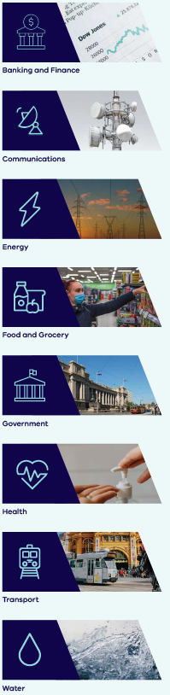
Critical infrastructure in Victoria
Critical infrastructure supports our most basic needs: safe drinking water, food, health services, reliable transport, energy for homes and industry, access to banking, finance and government services, and global communications networks to connect us socially and in business. Critical infrastructure includes the physical facilities, supply chains, systems, assets, information technologies and communication networks which, if disrupted, degraded or lost for an extended period, would significantly impact on the social or economic wellbeing of the community.
Eight critical infrastructure sectors provide Victorians with access to quality and reliable services. The eight sectors are listed to the right.
Under Part 7A of the Emergency Management Act 2013, Energy, Water and Transport are identified as essential sectors.
In a changing environment, the increased threat of disruption means critical infrastructure must continue to build resilience to a growing range of hazards. Increased cyber security threats, pandemics, larger populations, just-in-time supply chains, extreme weather events and climate change are just some of the challenges for Victoria’s critical infrastructure.

The Victorian Critical Infrastructure Framework
Victoria’s Critical Infrastructure Resilience Framework includes policy and legislation to support the ongoing resilience of the state’s critical infrastructure.
There are four key parts to the framework (Table 1). Partnership between critical infrastructure owners and operators and government is a key component.
Table 1: The four key parts of the Victorian Critical Infrastructure Resilience Framework
The four key parts of the Victorian Critical Infrastructure Resilience Framework
Critical Infrastructure Resilience Strategy | Policy outlining Victoria’s critical infrastructure arrangements and the importance of continually building the resilience of these assets, systems and services.
Part 7A of the Emergency Management Act 2013 | Legislation to help identify and assess what Victoria’s critical infrastructure assets are and record them on a register. Emergency Management Victoria (EMV) operates this register and uses it to enhance the security and resilience of identified critical infrastructure assets. Owners and operators of the most important infrastructure – assessed as ‘vital’ – must complete emergency risk management planning.
Critical infrastructure regulations | Regulations to support the implementation of legislation and establish standards for the assessment process and emergency risk management exercises.
Ministerial Guidelines for Critical Infrastructure Resilience | Guidelines to assist industry and government to meet their obligations, and to promote consistency, by detailing requirements and processes.

Resilience is defined by the Victorian Government as the capacity of individuals, communities, institutions, business and systems to survive, adapt and thrive no matter what kind of chronic stresses and acute shocks they experience.
The critical infrastructure framework takes an ‘all hazards, all emergencies’ approach to building resilience, which reflects the potential for both natural and human-induced events that can disrupt or damage critical infrastructure.
This year, critical infrastructure faced a range of significant and varied emergencies – such as the 2019-20 Victorian bushfires, the coronavirus (COVID-19) pandemic and multiple cyber security incidents. In each of these events, the framework provided a strong foundation for working together, demonstrating the value and benefit to the Victorian community.

The Victorian Critical Infrastructure Model
Recognising its importance to the community, Victoria has legislation that requires government to assess the criticality of infrastructure in the essential sectors of Energy, Water and Transport.
Assets and systems within these sectors are assessed as being of either ‘vital,’ ‘major,’ ‘significant’ or ‘local’ importance to Victoria’s economic and social wellbeing (Figure 1).
Owners and operators of vital critical infrastructure must undertake an annual resilience improvement cycle for industry and government to articulate the emergency risks to the supply of essential services to the Victorian community, and to develop risk management strategies to mitigate and manage those risks. As part of this cycle, owners and operators undertake an exercise to test their preparedness for a key emergency risk.
Figure 1: The Victorian Critical Infrastructure Model
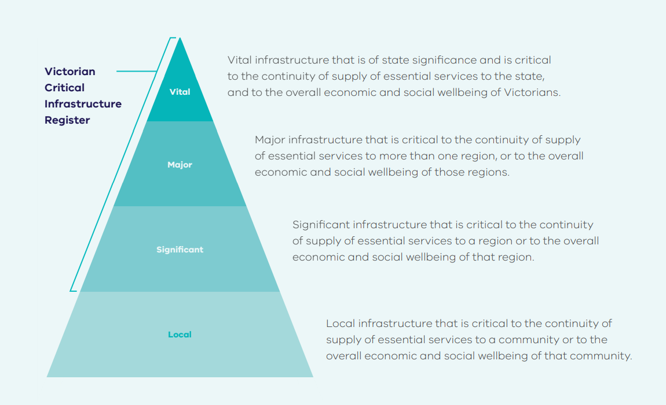

Victoria’s Sector Resilience Networks
Each of Victoria’s eight critical infrastructure sectors convene a Sector Resilience Network (SRN). These networks are a cornerstone of Victoria’s critical infrastructure arrangements. The SRNs provide a solid foundation for collaboration between critical infrastructure owners and operators, and government.
Each SRN is coordinated by a government department and comprises critical infrastructure owners and operators. Coordinating departments are shown in Table 2.
Building on previous networks under a different name, the SRNs have been in place since 2015. The SRNs have established trusted networks with a focus on resilience, sharing information, understanding shared risks and interdependencies.
Table 2: Coordinating departments for Victorian critical infrastructure sectors
Sector | Responsible department
Banking and Finance | Department of Treasury and Finance (DTF)
Communications | Department of Jobs, Precincts and Regions (DJPR)
Energy | Department of Environment, Land, Water and Planning (DELWP)
Food and Grocery | Department of Jobs, Precincts and Regions (DJPR)
Government | Department of Premier and Cabinet (DPC)
Health | Department of Health and Human Services (DHHS)
Transport | Department of Transport (DoT)
Water | Department of Environment, Land, Water and Planning (DELWP)

Networks meet regularly during the year to share information, work together on common concerns and opportunities to collaborate within and across sectors to build resilience through focused activities. Representatives from relevant emergency service organisations and the Inspector-General for Emergency Management (IGEM) also attend these meetings as observers.
Increasingly over the past year, these networks have assisted emergency response to inform better situational awareness and understand risks to continued provision of services, including impacts to other critical infrastructure and the community.
Owners and operators participate in these networks on a volunteer basis. Victorians continue to benefit from their willingness to share their expertise, knowledge and focus on resilience during preparedness, response and recovery.
Each year, the sectors produce Sector Resilience Plans (SRPs) for the State Crisis and Resilience Council (SCRC). The SRPs outline overall sector resilience, identify key emergency risks and areas of focus for resilience improvement activities. The SRPs are used to develop this annual report, which summarises the resilience of all sectors.
State level engagement is complemented by the work of the Commonwealth’s Trusted Information Sharing Network (TISN), a national critical infrastructure network chaired by and comprised of industry members.

The changing risk environment
Critical infrastructure operates in a dynamic environment. As the world becomes more interconnected and interdependent, the range of potential disruptions and their consequences is broadening.
Climate trends indicate that critical infrastructure must prepare to be more resilient to natural events, as climate change influences their frequency and severity. For example, heat extremes of all kinds are projected to increase – bringing implications for human health and the operation of critical infrastructure. In many parts of Australia, what are now 1-in-20-year extreme hot days are expected to occur every two to five years by the middle of the century. According to the CSIRO, Australia has seen:
- An increase in average annual temperature of around 1.5ºC since 1850
- Increased extreme heat events
- Warmer sea temperatures
- Higher sea levels
- Reduced rainfall in southeast and southwest Australia
- An increase in some rainfall extremes.
The Royal Commission into National Natural Disaster Arrangements has also warned in its Interim Observations of “more frequent and intense” natural disasters in coming decades, reflective of Australia’s bushfire experience in 2019-20. An ongoing focus on critical infrastructure resilience is necessary to meet emerging risks.
Victoria’s experience of significant emergencies in recent years has demonstrated:
- An increase in emergencies that are not bound by geography (for example, cyber threats)
- More frequent emergencies, including emergencies of longer duration requiring more time for recovery; for example, extended bushfire seasons and the ongoing coronavirus (COVID-19) pandemic
- Potential for concurrent emergencies (for example, significant fires occurring in multiple states, or two or more types of emergencies at once)
- Increased reliance on global technologies and supply chains.

Resilient infrastructure is supported by owners and operators’ business continuity plans, which identify their key emergency risks and support preparations for the changing risk environment.
Critical infrastructure prepares for potential disruption to energy supply
The threat of a heatwave and potential disruption to energy supply led to a discussion exercise at the All Sectors Resilience Networks Forum in July 2019. Critical infrastructure owners and operators considered potential impacts to their operations. In the lead-up to summer, owners and operators reported to government on their business continuity plans.
Victoria has recently reviewed its state-level emergency risk assessment, which establishes the State’s emergency risk profile. Pandemic is identified as one of the State’s significant risks – in line with Victoria’s continued experience of the global COVID-19 pandemic.
The changing risk environment has led to policy decisions made by the Commonwealth Government, including its proposal to increase the scope of the Security of Critical Infrastructure (SOCI) legislation. Proposed amendments seek to further strengthen and improve the security and resilience of national critical infrastructure and systems across all hazards. Owners and operators of infrastructure most critical to the nation will need to assess their key emergency risks against all hazards and report to government, in an arrangement similar to Victoria’s. Increased reporting and mitigation of cyber security threats will also be required. The Commonwealth is also undertaking a TISN refresh to enhance industry-government engagement.

The year in review

Victorians faced multiple emergency events in 2019-20
The last 12 months have been particularly challenging for the community. Over the year, Victoria has faced several major emergencies, severely impacting communities and businesses. The capacity of critical infrastructure to continue to provide services has been tested, most notably by the Victorian bushfires and coronavirus (COVID-19) pandemic. While these emergencies did challenge services provided by critical infrastructure, they also highlighted the strengths of Victoria’s established critical infrastructure arrangements and industry commitment to minimising impacts to the community when infrastructure is damaged or challenged by emergencies.
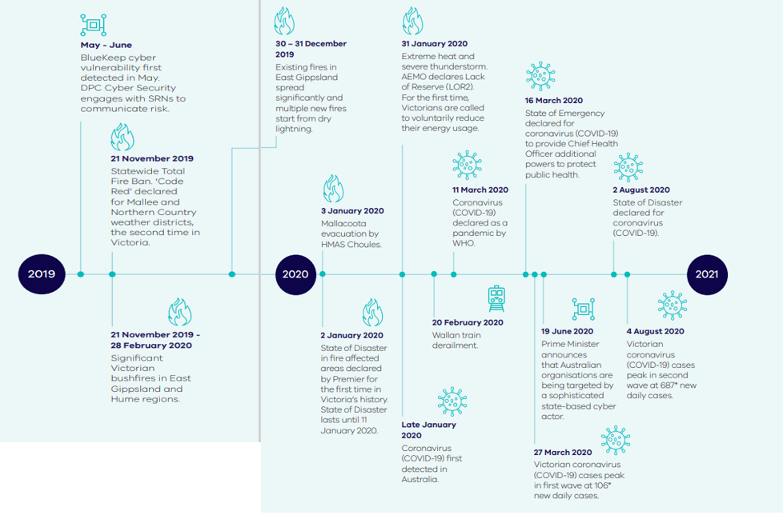
Figure 2: Timeline of emergency events in 2019-20
*Note there will be some discrepancy in the highest recorded daily cases and the numbers originally reported in the Premier's daily media conference. Data reported to the Department of Health and Human Services is continuously cleaned and processed, which includes the removal of duplication and allocating cases to the date of test, rather than the date of notification to the department. Source: https://www.dhhs.vic.gov.au/victorian-coronavirus-covid-19-data.

During these emergencies, critical infrastructure owners and operators responded by:
- Providing expertise and knowledge to facilitate early identification and management of risk
- Demonstrating shared responsibility and relying on trusted relationships – working within and across sectors, government and emergency services to restore services and minimise the impact to the community
- Activating their business continuity plans
- Demonstrating adaptability, agility and resilience
- Integrating with emergency management arrangements.

Emergency events impacting Victorian critical infrastructure
This year’s emergencies, particularly the 2019-20 Victorian bushfires and coronavirus (COVID-19) pandemic, have challenged critical infrastructure’s continued supply of services to the community.
Cyber security threats (2019-20)
The Victorian Department of Premier and Cabinet (DPC) and Commonwealth Australian Cyber Security Centre (ACSC) worked closely with SRNs to engage with critical infrastructure industry to improve their cyber resilience and reduce their exposure to cyber security threats with the potential to disrupt service delivery. During the BlueKeep incident in mid-2019 – which exposed a Microsoft vulnerability that leaves users open to attack from malicious actors – the SRNs were engaged in the emergency management response, enhancing situational awareness, threat mitigation, and reducing the impact on services and the community. In response to an Advanced Persistent Threat (APT) campaign targeting Australian networks in June 2020, the National Cyber Security Committee (NCSC) elevated Australia’s cyber alert level and took proactive steps to mitigate risk to critical infrastructure and government departments.

‘Code Red’ day and extreme heat (21 November 2019)
Code Red is the highest Fire Danger Rating in Victoria and clearly identifies the potential for the worst possible bushfire conditions. Based on updated predictions of fire risk from the Bureau of Meteorology, a state-wide Total Fire Ban (TFB) was declared on Wednesday 20 November 2019 for the following day, including a Code Red Fire Danger Rating for the Mallee and Northern Country weather districts. In response, plans were enacted by critical infrastructure owners and operators in preparedness. While government and industry prepared for the Code Red conditions, it was severe weather (high winds) on the day that led to approximately 300,000 customers losing power, with the majority restored by the following morning. The outages also impacted some water and telecommunications facilities. This was the second Code Red determination in Victoria since its introduction in 2010 and the first under the current emergency management arrangements.

2019-20 Victorian bushfires (21 November 2019 – 28 February 2020)
Unprecedented fires in the Hume and Gippsland regions of Victoria resulted in the loss of five lives, destroyed at least 347 residential dwellings, shrouded cities, towns and communities in smoke resulting in hazardous air quality recordings, burnt over 1.5 million hectares, and had a devastating impact on the natural environment and wildlife. A State of Disaster was announced on 2 January 2020 and was extended until 11 January 2020. The bushfires impacted over 120 communities and included the largest evacuation in Victoria’s history.

Wallan train derailment (20 February 2020)
A New South Wales XPT passenger train travelling from Sydney to Melbourne derailed just outside of Wallan, Victoria. Two train staff were killed, three passengers were seriously injured and 36 received minor injuries. The derailment caused the closure of the North East and Tocumwal railway lines, impacting freight and V/Line services to Seymour, Shepparton and Albury.

Coronavirus (COVID-19) pandemic
Coronavirus (COVID-19) was first detected in December 2019. On 30 January 2020, the Director-General of the World Health Organization declared the outbreak to be a Public Health Emergency of International Concern. Coronavirus (COVID-19) was first confirmed in Australia in late January and declared a pandemic on 11 March. In Victoria, a State of Emergency was declared under the Public Health and Wellbeing Act 2008 on 16 March. Since then, risk controls and mitigations have been in place to prevent and control the spread of the virus and damage to the community and the State of Victoria. The pandemic and its impacts are ongoing at the time of this report.

How owners and operators responded to the 2019-20 Victorian bushfires and coronavirus (COVID-19) pandemic

2019-20 Victorian bushfires
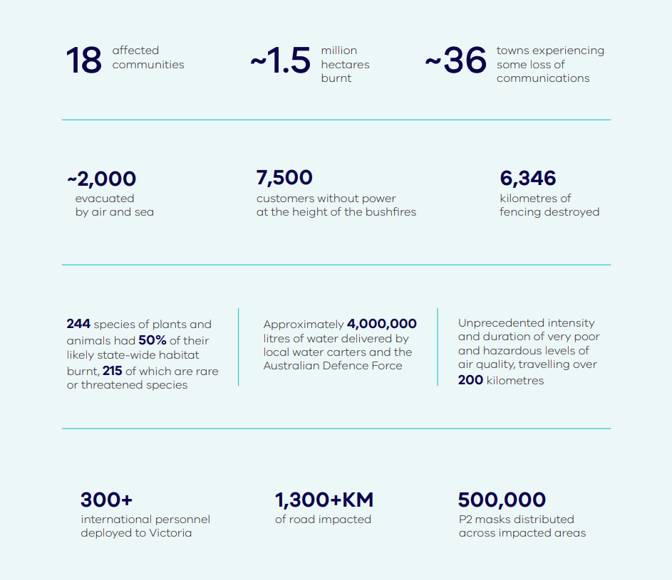
Figure 3: 2019-20 Victorian bushfires statistics
Over the 2019-20 summer, Victoria suffered its most devastating bushfire season in over a decade. During late November and December 2019, a number of significant fires started and continued to burn in Gippsland and the north east of Victoria. Fires were also burning across other Australian states, including at the New South Wales border, during what was Australia’s hottest and driest year on record.
Five lives were lost in Victoria and at least 347 homes and 700 non-residential structures destroyed, including business premises, one school and one kindergarten.
The bushfires severely impacted communities within and surrounding the fire footprint. A significant contribution to this distress was the prolonged failure of some essential services because of damage to critical infrastructure.
Towns were left without power, road access, communications, clean water, access to health services, restricted ability to purchase food, groceries and other goods, such as fuel for generators.
The bushfires directly affected 18 communities, including the town of Mallacoota, where 5,000 people fled to the coastline as the out-of-control bushfire approached.
On 2 January 2020, the Premier announced a State of Disaster in fire-affected areas under Section 23 of the Emergency Management Act 1986, based on advice from the Minister for Police and Emergency Services and the Emergency Management Commissioner. This was the first time a State of Disaster had been declared in Victoria.

Impacts to critical infrastructure and essential services
The bushfires caused a range of damage or disruption to services provided by critical infrastructure. Some examples included:
- Damage to roads – 1,300 km of arterial roads were inaccessible and closed – preventing evacuation, restoration of critical infrastructure essential services and supply of necessary goods and services such as food, fuel for generators, grocery and medical supplies
- Damage to the AusNet Services’ electricity distribution network, causing 7,500 customers to be off supply. While customers were progressively restored, some remained off supply for an extended period
- Full or partial loss of communications in some towns, primarily due to a loss of power, impacting Telstra, Optus and National Broadband Network (NBN) customers
- Contamination of drinking water and increased community water demand, due to heat, asset protection and firefighting needs
- Disruption of food supply lines, preventing the delivery of food and grocery to some communities
- Disruption to telecommunications links impacted EFTPOS and ATM services
- Intermittent disruptions to the services of several health services and bush nursing centres.

Case study 1: 2019-20 Victorian bushfires
The impact of critical infrastructure failure on communities
The closure of the Princes Highway severely impacted individuals, businesses and communities. The closure of the highway and many other roads in the area isolated communities, who were unable to leave and faced with limitations to relief and supplies that could be brought in.
The prolonged closure of a key arterial road prevented the restoration of critical infrastructure services.
Approximately 36 towns experienced some loss of communications, leaving some people unable to receive or access emergency alerts, public information, warnings, road closure details and community information, or contact friends and family. This resulted in safety concerns and a high level of fear and anxiety for bushfire impacted communities.
At the height of the bushfires, damage to AusNet Services’ network led to 7,500 customers losing power supply. Power was progressively restored, with the last 19 customers reconnected on 24 February 2020. Reconnection was delayed by the severity of damage to the distribution network as well as ongoing fire conditions, safety concerns with opening access roads, and difficulty in accessing some terrain.
Normal supply routes had to be altered, in some cases adding up to 1,000km to the trip. Supermarkets required generators to maintain food quality.

How the critical infrastructure sectors responded
Sharing a common goal of community safety, critical infrastructure owners and operators activated their emergency response plans, using established networks to connect with government, other operators, emergency services and not-for-profit organisations. Initially, this was to provide interim services before access to the road network enabled permanent service restoration. Their response included:
Road clearing operations
The Transport sector coordinated the assessment of damage and restoration of the road network, working with multiple departments and agencies. The road network was significantly impacted and access was cut to a number of communities over a prolonged period. A multi-agency Road Access Taskforce was established, including significant Australian Defence Force support.
Restoring power supply
AusNet Services worked closely with DELWP, the State Control Centre and locally with Incident Control Teams to restore power supply to communities in bushfire affected areas. As a temporary measure, large-scale back-up generators were deployed to some areas to support people and businesses without power. When road access was restored, and crews could safely access impacted areas, AusNet Services worked to repair damage to the electricity distribution network.
Government coordination
More than 3,000 state public servants helped fight the fires and assist with relief and recovery efforts. Government also stood up the Bushfire Response and Recovery Taskforce to coordinate activities across government and streamline processes for affected communities.
Health services for initial response
First aid and medical support were provided to communities via emergency relief centres, coordinated by local government. More than 500 clinicians expressed interest in assisting the initial response, and more than 30 short-term locum contracts were provided to support health services and local GP practices.
A public health emergency order was put in place, enabling pharmacies to dispense prescription-only medicines to people affected by the bushfires if they did not have a prescription.
prescription.
National engagement and collaboration
During the fires, liaison was conducted via the Commonwealth’s TISN, a national critical infrastructure network chaired and comprised of industry members. This provided invaluable information on impacts to critical infrastructure, and solutions to respond to the supply needs of communities, particularly via nationally regulated sectors.
Temporary communications services
Mobile carriers established temporary restoration measures, primarily the installation and refuelling of generators; supported affected communities by providing satellite and mobile phone handsets; and provided access to data and temporary broadband satellite services at evacuation centres.
Emergency relief drinking water
Between 8 January and 11 May, 488 bushfire-affected households, community houses and Bush Nursing Centres in East Gippsland and North East Victoria received water tank flushes and refills as part of the Emergency Relief Drinking Water Program. Local water carters and the Australian Defence Force delivered an estimated 4,000,000 litres of water.
A mutual aid coordination cell was activated by South East Water to support North East Water and East Gippsland Water, with assistance from other water corporations. Previously developed mutual aid guidelines enabled a rapid response from the Water sector.
Providing essential food and grocery items
The Food and Grocery sector, through DJPR, worked with the State Control Centre on response and relief efforts. Companies such as Metcash and Dyers collaborated with DJPR, EMV, the Australian Red Cross, Victoria Police, and the Australian Defence Force to deliver food and groceries to isolated communities.
Mutual aid arrangements for banking and finance
The Banking and Finance sector triggered sector-wide mutual assistance arrangements to support efforts at fire impacted locations, such as accessing generator power for ATMs and replenishing cash on behalf of members.

The coronavirus (COVID-19) pandemic
The coronavirus (COVID-19) pandemic continues to have a significant global impact requiring effective planning, coordination, adaptability and response.
The first confirmed case in Australia was detected in late January 2020, following multiple cases internationally in December 2019. By late March, new cases in Victoria had peaked for the first time and the risk of exponential spread within the community was a significant concern.
A State of Emergency under the Public Health and Wellbeing Act 2008 was declared by the Victorian Minister for Health on 16 March, on advice from the Chief Health Officer and the Emergency Management Commissioner. The State of Emergency provides the Chief Health Officer additional powers to issue directions to help contain the spread of coronavirus (COVID-19) and keep Victorians safe.
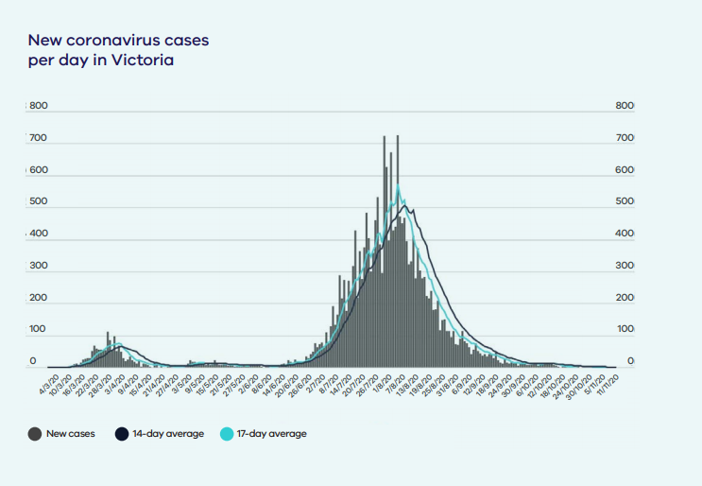
Victoria’s first wave, peaking in late March with just over 100 new daily cases, was followed by a much higher second wave beginning in June, which peaked on 5 August with 725 new daily cases reported (later revised to 686 following data consolidation). A State of Disaster was declared by the Premier on 2 August under Section 23 of the Emergency Management Act 1986. This declaration gives the Victorian Government the powers and resources it needs to keep Victorians safe. Tragically, over 800 Victorians have died at the time of this report, with significant impacts to community members and the economy.

Figure 4: Covid cases graph

Coronavirus (COVID-19) has challenged critical infrastructure industry and government
For critical infrastructure, the pandemic has prompted an unprecedented mobilisation of resources and innovation to ensure continuity of services to the community.
To limit the transmission of coronavirus (COVID-19), many Victorians were required to remain at home. This would have been considerably more difficult and caused greater disruption to economic activity without the reliable supply of services such as power, communications, food and grocery, water and sanitation.
The continued supply of these essential services during this challenging emergency highlights the resilience of Victoria’s critical infrastructure. Given the potential for significant disruption, the minimal impact to service delivery demonstrates capability the sectors to adapt and respond. Owners and operators have responded to the challenges of maintaining COVIDSafe workplaces, disruptions to international and interstate supply chains, impacts of border closures, and restricted practices for workforces. Some examples include:
Proactive exercise for confirmed coronavirus (COVID-19) case in the workplace
The Water sector conducted an exercise to build knowledge and a common understanding of actions to be undertaken by the sector in the event of a confirmed case in the workplace.

State and national engagement
Regular SRN meetings and national forums have been occurring to share information and raise common issues. SRNs have reported regularly through their coordinating departments, enacted business continuity arrangements and actively planned to ensure the sectors were prepared to deal with a potential outbreak.
Health coordination
Taskforces have been established to ensure whole-of-sector engagement, including a health services pandemic leadership team and a clinical leadership expert group.
Health workforce planning established a portal to identify additional workforce resources, onboard new staff, upskill current staff and repurpose current medical/nursing student cohorts.
The sector developed health surge critical care workforce models and a dynamic workforce modelling tool to identify needs in different coronavirus (COVID-19) scenarios.

National Supermarket Taskforce
This taskforce, established at the Commonwealth level for the Food and Grocery sector, coordinates a national response to the surge in product demand and facilitates sharing information and best practice.
Rotating operational teams
Rotating teams have been established by the energy sector across main and redundancy sites, to ensure continuity of service in case of an outbreak.

Owners and operators worked together and with government to address risks to continued service supply, demonstrating the community benefits of the effective operation of Victoria’s critical infrastructure arrangements.
Case study 2: COVID-19 pandemic
Collaboration between major supermarkets
In March, following the coronavirus (COVID-19) outbreak, Victoria experienced a wave of community led ‘panic buying’ as shoppers started to stock up on toilet paper, hand sanitiser and other key household items such as rice, flour and pasta. This put pressure on supply chains, as demand spiked unexpectedly, leading to product shortages on supermarket shelves and impacting availability for vulnerable members of the community. In response, Australia’s largest supermarket chains worked together and in partnership with government to minimise shortages.
A national Supermarket Taskforce was established to focus on cross-sector collaboration under an interim authorisation from the Australian Consumer and Competition Commission. Members worked together on buying limits, opening hours, and coordination of public messaging to reassure customers of Australia’s food supply capacity.
Manufacturers were able to help by reducing production of non-essential product lines, changing pack sizes and increasing maximum production with new ‘direct to store from supplier’ arrangements.
The Food and Grocery sector liaised with the State Government to reduce delivery curfews to manage increased freight demand and opened ‘pop up’ centres to increase distribution and warehousing capacity.
As a result, shortages of key goods were minimised.

Looking forward

Priorities for 2020-21 and beyond
During 2020-21, the coronavirus (COVID-19) pandemic will continue to present challenges and unpredictability for critical infrastructure and the community relying on these services.
Concurrent emergencies – for example, a major flood during the pandemic – will further test the capability, capacity and resilience of critical infrastructure.
SRNs will focus their future resilience building activities on lessons learned from the 2019-20 bushfires and coronavirus (COVID-19), reflecting on the effectiveness of communication between industry and government and examining an aspect of their supply chain which could be impacted by an emergency.

Shared emergency risks for sectors in 2020-21
A number of sectors have identified the following as key emergency risks and areas of potential focus for future resilience improvement initiatives:
- Pandemic
- Climate change
- Cyber security
- Severe weather and extreme heat
- Flood
- Electricity supply disruption
- Fire
- Major security event
- ICT outage.
The coronavirus (COVID-19) pandemic is a significant global health, economic and social crisis that will continue to challenge all communities. It is the largest economic shock the world has experienced in many decades, and the compounding effects will be long-standing and difficult to navigate. The pandemic will continue to place unparalleled stress on the health, finances and social wellbeing of all Victorians. It will also continue to test the resilience and ability of critical infrastructure sectors to provide services essential for Victoria’s social and economic wellbeing.

Critical infrastructure interdependencies
Critical infrastructure rarely operates in isolation. Delivery failure in one service often results in disruption or failure in another. A resilience approach to managing risks to critical infrastructure considers the interdependencies across systems, networks and other sectors.
The impact of critical infrastructure interdependencies, and the cascading effects on the community’s experience of emergencies, is clearly highlighted through the following case examples.
Case study 3: 2019-20 Victorian bushfires
Dependency of communication on power supply
Community impact: Community members unable to receive or access emergency alerts, public information, warnings, road closure details and community information.
A report by the Australian Communications and Media Authority (ACMA) found that 1,390 communication facilities were impacted by bushfires, 324 in Victoria. Of all affected facilities, only 1 per cent of impacts were caused directly by fire damage, and 88 per cent had permanent restoration of service once power was restored to the site.
Lack of communication services resulted in service failure of other sectors, including Food and Grocery, Banking and Finance, and Health, as well as community safety concerns.
Figure 5: Communications outage incidents, by location and root cause
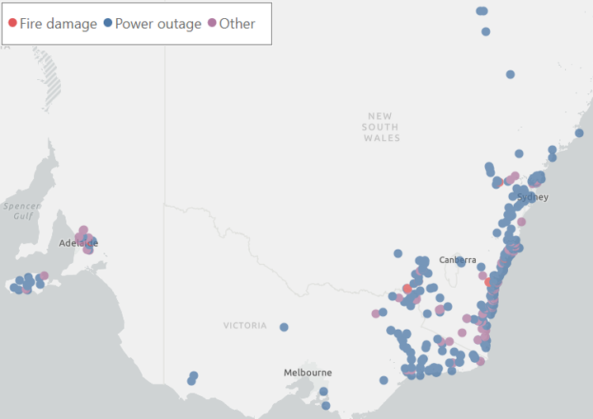

While a dependency on power is well understood, the 2019-20 bushfires also highlighted the significant inter-dependencies of other sectors impacted by damage to the road network.

Case study 4: 2019-20 Victorian bushfires
Dependency on roads and the transport sector
Community impact: Towns are left isolated and without access to essential supplies.
Over 1,300 km of arterial roads were inaccessible and closed due to fire activity, causing 18 towns to be physically isolated between Victoria and New South Wales east of Omeo.
The Princes Highway, a main arterial road between Sydney and New South Wales, was closed. There was significant damage to road signs, guideposts, crash barriers and drainage infrastructure. Hazardous trees and debris had to be cleared before it was safe to reopen roads in the area.
Prolonged access limitations caused significant disruption and delayed the restoration of other critical infrastructure, such as energy and communications.
In the township of Mallacoota, nearly 2,000 residents and visitors had to be evacuated by the navy and air force.
Supplies of food and groceries were disrupted. Alternatives were implemented, such as flying or shipping in food, medicine and fuel to power generators. These alternatives were hampered by smoke affecting visibility and vessel size restrictions for ships delivering essential supplies.
Victoria’s Sector Resilience Networks (SRNs) were activated, working with government and emergency services. Owners and operators of affected critical infrastructure worked as Emergency Management Liaison Officers at local, regional and state levels, providing relief and restoring services amidst the challenge of road closures. Coordination provided by a Roads Access Taskforce ensured necessary resources and collaboration across multiple agencies, including the Australian Defence Force.

Case study 5: COVID-19 pandemic
Planning for interdependencies by Sector Resilience Networks
Community impact: Service supply continuation.
In contrast to the response focus for the bushfires, the prolonged nature of the coronavirus (COVID-19) pandemic provided the opportunity for sectors to progressively understand their interdependencies, plan and coordinate their response across sectors.
The networks at the state and national level (SRNs and TISNs), were essential to early understanding of risk across sectors and developing mitigation strategies. This collaboration between industry and government, and the resilience of critical infrastructure, resulted in minimal disruption of services during this challenging time for the Victorian community.

The following section provides an overview of the resilience of the eight critical infrastructure sectors, including key emergency risks, key dependencies, and completed and proposed resilience improvement initiatives.

Victoria’s critical infrastructure sectors

Banking and Finance
The Banking and Finance sector operates within a globally competitive financial services market. Within Victoria, and more broadly Australia, the sector consists of providers ranging from small and medium-sized entities to multinational financial institutions. These entities operate subject to a range of nationally regulated arrangements. Operations are structured around common, interdependent systems that support banking and finance transactions.
Recognising that the sector operates on a national basis and that it is subject to Commonwealth law and regulation, the Victorian Banking and Finance SRN coordinates its activities through the national TISN Banking and Finance Sector Group (BFSG).

Sector overview
- There are 45 financial sites identified as operationally important in Victoria. Two of Australia’s major four banks host headquarters in the state.
- The sector consists of financial service providers (for example, banks, credit unions, credit providers, transactional service providers), insurance and wealth management service providers, various settlement entities and national regulatory agencies.
- The sector delivers essential services and products that include the operation of financial, insurance and wealth management markets and products; operation of payment, clearance and settlement activities across the sector; and access to depositor funds and lines of credit.

Key stakeholders
- The big four banks (Commonwealth Bank of Australia, Westpac, National Australia Bank and Australia and New Zealand Banking Group), regional and merchant banks
- Settlement and regulatory agencies
- Insurance Council of Australia
- Australian Banking Association
- Within the state, Treasury Corporation of Victoria, State Revenue Office and Victorian Managed Insurance Authority.

Key assets and infrastructure
- Corporate headquarters
- Primary data centres
- Back-up data centres
- Call centres
- Operations/processing centres
- Trading centres
- Critical ICT systems, applications and processes.

Key risks
- Cyber security
- ‘Trusted insider’ threat
- Natural hazards (bushfire, flood, extreme heat)
- Health hazards (disease, epidemic and pandemic).

Key dependencies
- Electricity
- Water
- Gas
- Telecommunications.

Resilience improvement initiatives completed in 2019-20
- Noting the sector’s key threats are in the cyber realm, the BFSG continued its extensive engagement with national cyber security agencies, to stay across such threats.
- During the reporting period, the sector started planning a potential cyber security focused exercise.
- The sector pursued a range of activities to strengthen cross-sector coordination and continues to investigate options to ‘operationalise’ the BFSG during emergencies crossing multiple sectors.

Resilience improvement initiatives proposed in 2020-21
- Balance the sector’s ongoing coronavirus (COVID-19) response with continuous improvement through the BFSG.
- Build on the sector’s continuing efforts to ‘operationalise’ the TISN under cross-sectoral emergencies, in order to improve coordination.
- Establish common national arrangements and inform the Department of Home Affairs’ review of all the TISNs’ activities and roles.
- Consider relevant findings from the Royal Commission into National Natural Disaster Arrangements and IGEM Inquiry into the 2019-20 Victorian Fire Season.
- Continue to focus on cyber threats and conduct an exercise in the next reporting period (subject to resource availability).

Communications
The Communications sector comprises service providers offering fixed-line, mobile voice and broadband services operating at the wholesale and retail level, to meet growing demands of residential and business consumers. Communications networks support everything from home phones and WiFi to mobile phones, secure networks used by financial institutions, to major data centres located around the world.
Communications policy and regulation is primarily set at the national level and the Victorian Communications SRN actively participates in meetings of the Commonwealth’s TISN Communications Sector Group (CSG).

Sector overview
- Telstra and NBN Co are the major owners of fixed-line communications infrastructure. The progressive roll-out of high capacity, high speed fibre networks is likely to significantly change future business and customer behaviour, as more users move to the national broadband network and 5G network services delivered by the main telecommunications carriers. Both will bring about significant improvements and increased reliance on communication infrastructure across Victoria.
- Telstra, Optus and TPG Telecom (formerly Vodafone Hutchison Australia) are the three primary infrastructure owners of mobile services. About 60 mobile virtual network operators purchase wholesale end-to-end mobile services (including transmission) from the infrastructure owners, to provide retail services.

Key stakeholders
- Carriers, particularly NBN Co, Telstra, Optus, TPG Telecom and VicTrack
- Retail service providers
- Content providers
- Application developers.

Key assets and infrastructure
- Copper networks
- Hybrid fibre-coaxial networks
- Fibre-optic cable networks
- 3G and 4G technology (particularly mobile telephone and wireless internet towers)
- 5G technology
- Satellite ground stations
- Exchanges, points of interconnection (POIs) and data centres
- Carrier equipment located at residential and business premises (for example, broadband modems, satellite receivers, fixed wireless radios)
- Broadcast TV and radio transmission towers.

Key risks
- Cyber security
- Fire
- Extreme weather (including flood and storm)
- Pandemic
- Heatwave
- Security
- Electricity disruption
- Failure of communication assets
- Disruption of underground and overhead cables.

Key dependencies
- Electricity supply
- Human resources
- Liquid fuels
- Transport (infrastructure access)
- Supply chains.

Resilience improvement initiatives completed in 2019-20
- Developing the maturity of the Communications SRN membership.
- Engagement and collaboration at the national level, including:
- Regular meetings of the TISN CSG, particularly during the initial COVID-19 outbreak, where weekly meetings were implemented to maintain situational awareness and contribute to information sharing and response initiatives.
- Communications SRN member participation in a Resilience Expert Advisory Group (REAG) workshop and TISN engagement session, to explore cross-sector dependencies and jurisdictional emergency management arrangements.
- Participating in forums with other critical infrastructure sectors, including:
  - A critical infrastructure pre-season emergency preparedness briefing. This included all sectors and provided insights into key seasonal outlooks by the Bureau of Meteorology and the Australian Energy Market Operator (AEMO).
- Developing a more sophisticated, shared understanding of the criticality of communications infrastructure. In response to unprecedented emergencies in 2019-20, the traditionally competitive sector worked together on issues of common concern, in collaboration with Commonwealth and state government networks.

Resilience improvement initiatives proposed in 2020-21
- Lead, contribute to and learn from debriefs, reviews and inquiries into the 2019-20 bushfires (namely, the IGEM Inquiry into the 2019-2020 Victoria Fire Season and the Royal Commission into National Natural Disaster Arrangements) and the coronavirus (COVID-19) pandemic.
- Develop and refine standard operating procedures and protocols for disruptions to communications services arising from emergencies.
- Develop a deeper understanding of communications supply chains disrupted during the 2019-20 bushfires and coronavirus (COVID-19).
- Participate in an exercise exploring the impacts to telecommunication services from a natural hazard or key supply chain failure.
- Engage with Commonwealth departments including Emergency Management Australia, the Department of Home Affairs and Department of Infrastructure, Transport, Regional Development and Communications to identify topics of interest to the sector.
- Contribute to the rollout of the Strengthening Telecommunications Against Natural Disasters (STAND) package and review of the national Critical Infrastructure Resilience Strategy.

Energy
A variety of energy sources power Victorian homes, workplaces, businesses, transport, essential services (for example, water supply) and community facilities. Victoria’s energy sector comprises three privately owned and operated sub-sectors – electricity, gas and liquid fuels – which form part of national networks that import and export between states and internationally.

Sector overview
The sector includes raw materials, processing plants, energy production, generation facilities, storage facilities, transmission and distribution networks.
Victoria’s energy assets are owned and operated by multiple privately-owned organisations.

Key stakeholders
- Producers and distributors of electricity, gas and liquid fuel products and services.
- Energy markets, AEMO, government regulators and the Victorian and federal governments.
- Victorian communities and businesses, including other critical infrastructure sectors dependent on the energy sector.

Key assets and infrastructure
- Electricity: generators, high and low voltage transmission and distribution systems
- Gas: production, receiving, processing and storage facilities; transmission and distribution systems
- Liquid fuels: import facilities, fuel refineries, storage, distribution systems (pipelines and transport) and retail outlets.

Key risks
- Cyber security
- Pandemic
- Major plant failure
- Physical intrusion or attack
- Fire
- Extreme temperature
- Drought
- Workforce issues
- Severe weather
- Loss of electricity, gas supply, or liquid fuel storage
- Loss of communications.

Key dependencies
- Electricity generation, transmission, distribution and mines
- Gas extraction, production, storage, transmission and distribution
- Liquid fuels including ports and road networks
- Other dependent critical infrastructure (such as water, communications and transport).

Resilience improvement initiatives completed in 2019-20
- The Energy SRN participated in two major national cyber security exercises alongside AEMO, state and federal governments and the Australian Cyber Security Centre.
- In line with the three-year risk assessment cycle, DELWP undertook a review in April 2020 to assess the sector’s 2019-20 risk profile.
- DELWP worked with the Energy SRN to undertake a review of interdependencies, including the development of a more detailed Statement of Assurance reporting process.
- Ongoing engagement with the sector around coronavirus (COVID-19) impacts and mitigation.

Resilience improvement initiatives proposed in 2020-21
- A joint exercise between Energy and Transport sectors to consider liquid fuel supply chain issues and dependencies resulting from a shutdown of ports.
- Proposed DELWP-led exercise to identify opportunities for enhanced communication between regional and incident control teams, and the energy industry; as well as participation in both state and national exercises for gas and electricity.
- During the 2020-21 resilience cycle, the Energy SRN will explore events which require sector-wide consequence management and build on individual resilience initiatives. Lessons will be shared at SRN meetings.
- Focus on key risks for the sector (cyber security, major plant failure and physical intrusion/attack) and universal themes for all sectors (lessons learned from the 2019-20 bushfires and coronavirus (COVID-19) pandemic, an aspect of the supply chain which could be impacted by an emergency, communication between industry and government).
- Consider relevant findings from the Royal Commission into National Natural Disaster Arrangements and IGEM Inquiry into the 2019-20 Victorian Fire Season.
- Industry to continue to improve cyber security health and maturity via internal capability programs, improved systems and engagement in AEMO’s cyber security framework.
- Explore interdependencies within and across sectors, including how events in one sector/subsector can impact on emergency resilience or response in another.

Food and Grocery
The supply of food and essential groceries to Victorians relies on a network of production, manufacturing/processing and packaging, distribution and retail outlets. Thousands of local and national businesses support this supply chain, and the sector has multiple dependencies on other critical infrastructure sectors and on imported goods. Major supermarkets provide critical links in food and grocery supply chains as they aggregate and distribute goods to customers.
Large food and grocery companies operate at the national level and Victorian Food and Grocery SRN members actively participate in meetings of the Commonwealth’s TISN Food and Grocery Sector Group and Supermarket Taskforce.

Sector overview
- The size and diversity of the Food and Grocery sector allows for a range of backups to ensure continuity of service.
- Supply chain moves low margin, high volume products using a ‘just in time’ business model, so food stocks (particularly perishables) and essential grocery items are limited.
- Subject to national competition laws and the Australia New Zealand Food Standards Code.

Key stakeholders
- Major supermarkets/distributors, particularly Coles, Woolworths, Aldi and Metcash
- Freight and logistics operators
- Industry associations
- Manufacturing/processing and packaging companies
- Food relief charities
- Regulators
- Government and auxiliary agencies within Victoria.

Key assets and infrastructure
- Manufacturing/processing plants
- Storage and warehousing
- Refrigeration systems
- Wholesale markets
- Distribution centres
- Data centres
- Retail outlets
- Freight and logistics operations, including heavy vehicle fleets and ‘last mile’ transport.

Key risks
- Natural disasters
- Pandemic
- Plant and animal disease
- Security, including cyber threats, foreign interference, organised crime and domestic terrorism.

Key dependencies
- Energy (electricity, gas, liquid fuels)
- Water
- Communications networks
- Transport networks (particularly ports, roads and freight rail)
- Banking and finance infrastructure
- Human resources.

Resilience improvement initiatives completed in 2019-20
- Membership of the Victorian Food and Grocery SRN was expanded beyond the major supermarkets, to include freight and logistics operators and the Australian Red Cross. Terms of Reference refreshed to align with the Strategy and highlight important operational role of members.
- SRN members participated in a Resilience Expert Advisory Group (REAG) workshop and TISN engagement session, to explore cross-sector dependencies and jurisdictional emergency management arrangements.
- DJPR has undertaken work to map food supply chains and identify critical operators, as well as key sector vulnerabilities. This contributed to the government’s broader coronavirus (COVID-19) supply chain stability project.
- DJPR is identifying lessons from the bushfires related to food and grocery supply with partners such as Metcash and the Australian Red Cross. This process will continue in 2020-21, including through the TISN Food and Grocery Sector Group.

Resilience improvement initiatives proposed in 2020-21
- Leading, contributing to and learning from debriefs, reviews and inquiries into the 2019-20 bushfires and coronavirus (COVID-19) pandemic, including the IGEM Inquiry into the 2019-20 Victorian Fire Season and the Royal Commission into National Natural Disaster Arrangements.
- Developing, refining and testing standard operating procedures and protocols for major disruptions to food and grocery supply.
- Consider further expanding membership of the Food and Grocery SRN to include major suppliers and industry associations.
- Developing a deeper understanding of supply chains for products that were in high demand during the peak of coronavirus (COVID-19) ‘panic buying’ – such as flour, rice, canned goods and toilet paper – in order to prevent any future supply disruption.
- Participating in an exercise that explores the impact of telecommunications failures on critical business systems, such as distribution centres, data centres and point of sale systems.

Government
The Victorian Government sector regulates, delivers and funds essential community services through departments and portfolio agencies. It interacts with all other critical infrastructure sectors and has ultimate responsibility in ensuring government services are delivered to citizens. Maintaining continuous delivery of these services in the event of disruptions relies on assets and infrastructure owned and operated by government and non-government entities.

Sector overview
Eight government departments and one agency are members of the Government SRN (the Departments of Premier and Cabinet; Treasury and Finance; Environment, Land, Water and Planning; Jobs, Precincts and Regions; Transport; Justice and Community Safety; Education and Training; Health and Human Services; and Victoria Police). The Victorian Public Service employs over 50,000 people while the broader Victorian public sector employs more than 270,000 people.

Key stakeholders
- Victorian government departments
- The Victorian community
- State Crisis and Resilience Council (SCRC)
- Victorian Secretaries Board (VSB) and its Integrity and Corporate Reform Sub-committee and State Significant Risk Inter-departmental Sub-committee
- Mission Coordination Committee
- Public Sector Administration Committee.

Key assets and infrastructure
- Staff and contractors
- ICT systems
- Digital technology (for example, vic.gov.au)
- Primary departmental and Victoria Police office locations, including all essential services (power, water, ICT) supplied to these sites.

Key risks
- Pandemic
- Climate change
- Cyber security
- Digitisation
- Demographic change.

Key dependencies
- Availability of staff and contractors to maintain service continuity
- Energy for ICT networks
- Transport for workforce availability.

Resilience improvement initiatives completed in 2019-20
- Development of a 2020 State Significant Risk Scan, undertaken by the State Significant Risk Inter-departmental Committee.
- New approaches and bespoke governance arrangements to maintain critical government services in response to emergencies during 2019-20, such as the Bushfire Response and Recovery Taskforce and establishing Missions to manage the coronavirus (COVID-19) response.

Resilience improvement initiatives proposed in 2020-21
- Understanding and applying the lessons learned from the 2019-20 Victorian bushfires and coronavirus (COVID-19) pandemic to enhance government sector resilience to other emergencies. In particular, planning workforce surge capacity and responding to recommendations from reviews and inquiries.
- Consider relevant findings from the Royal Commission into National Natural Disaster Arrangements and IGEM Inquiry into the 2019-20 Victorian Fire Season.
- Adapting government resilience initiatives to new public service workforce arrangements, to support increased remote working.
- Raising awareness of security threats that could impact the operation of government services, such as foreign interference.
- Strengthening the government’s resilience against cyber security threats which could affect the delivery of government services.
- The 2020 State Significant Risk Scan will be reviewed and updated in light of the coronavirus (COVID-19) pandemic.

Health
The Victorian Health sector is a large, highly regulated, complex and diverse network of service providers and health professionals. Its essential function is to deliver appropriate, accessible, and quality health services where and when they are needed.

Sector overview
- The broader health sector comprises sub-sectors, including health, public health, health education and health and medical research. It also includes organisations and businesses which provide medical services, manufacture medical equipment or medications, provide medical insurance, or otherwise support health care.
- Research bodies, medical boards and consumer health groups also support the sector.
- Delivery of services may be provided in settings such as hospitals, general practice (GP) clinics, specialist clinics, aged care facilities, community centres, bush nursing hospitals and centres, pharmacies, private homes, mobile services, and via phone and internet.

Key stakeholders
- Operators and essential service providers from across the Victorian Health sector, including major trauma health services, community-based health services, private and regional health services
- Ambulance Victoria
- Australian Red Cross Lifeblood
- DHHS
- Health Emergency Management Stakeholder Reference Group (HEMSRG)
- The Victorian community.

Key assets and infrastructure
- Hospitals
- Rural and regional health services
- Medical and specialist clinics
- Medical and diagnostic laboratories
- Ambulance branches
- Community centres
- Specialist rehabilitation facilities
- Psychiatric hospitals
- Specialist mother and child hospitals
- ICT systems
- Medical transport vehicles and air fleet
- Diverse mix of staff and specialist skills
- Critical medical supplies and devices.

Key risks
- Pandemic
- Public health events, such as biological, radioactive and contamination emergencies
- Major power disruption
- Major ICT outage
- Cyber security
- Climate change (particularly extreme weather events)
- Extreme heat
- Epidemic thunderstorm asthma
- Other extreme weather.

Key dependencies
- ICT systems
- Laboratories
- Waste management
- Internationally imported goods and services.

Resilience improvement initiatives completed in 2019-20
- Members of the Health SRN (HSRN) participated in Exercise Teapot, involving 113 participants from over 16 agencies, to build a greater understanding of the State Health Emergency Response Plan (SHERP) and explore escalation arrangements for a health emergency response.
- Members of the HSRN participated in the following multi-sector activities:
  - All Sectors Resilience Network Forum 2019
  - Critical infrastructure pre-season emergency preparedness briefing
  - Understanding Disaster Risk forum.
- Key stakeholder groups convened by DHHS were mapped during the early stages of the coronavirus (COVID-19) response, to ensure effective representation for whole-of-sector engagement and collaboration.
- The HSRN provided input to start shaping a strategic plan and forward work plan for the sector.

Resilience improvement initiatives proposed in 2020-21
- A focus on lessons learned from the 2019-20 bushfires and coronavirus (COVID-19) pandemic. This will include supporting awareness of findings and recommendations relevant to the Health sector from the Royal Commission into National Natural Disaster Arrangements and the IGEM Inquiry into the 2019-20 Victorian Fire Season.
- Supply chain analysis, to focus on a key supply dependency.
- Review of communication between DHHS and HSRN industry members and reflection on what worked well and opportunities for improvement.
- Continue to build understanding of criticality for the Health sector.
- Consider relevant findings from the Royal Commission into National Natural Disaster Arrangements and IGEM Inquiry into the 2019-20 Victorian Fire Season.

Transport
Victoria’s transport network is a geographically spread, complex system of road, rail, port and airport infrastructure that underpins much of the state’s economic and social functioning. Victoria’s roads and public transport systems allow people to travel to work, school and social activities, connect with family and friends, and access community services. The extensive freight network supports business development and trade.

Sector overview
- The transport network relies on a range of physical, electromechanical and electronic infrastructure to keep Victorians moving.
- Local, state, national and privately owned and operated assets and infrastructure make up the network.
- Public transport, rail (train and tram), roads, airports, ports and marine, freight and logistics, fishing and boating.

Key stakeholders
- Victorian communities and businesses
- Transport subsectors and stakeholders.

Key assets and infrastructure
- Roads
- Bridges and tunnels
- Traffic management and control centres, network control centres
- Heavy and light rail infrastructure
- Stations, stops and interchanges
- Depots
- Telecommunication systems
- Buses and coaches
- Ferries
- Cycling and walking paths
- Runways
- Terminals
- Aircraft control towers
- Wharves and berths
- Shipping channels
- Vessels
- Navigation aids
- Port operations control centres
- Ports, roads and rail networks
- Heavy vehicle road network
- Intermodal terminals
- Logistics services provider assets
- Boat ramps.

Key risks
- Pandemic
- Human resource disruption
- Electricity supply disruption
- Liquid fuel and gas supply chain disruption
- Major security event (including trusted insider threat, cyber attack)
- Legacy assets
- Skills shortage.

Key dependencies
- Energy (electricity, gas, liquid fuels)
- Telecommunications
- Transport operator control systems (signalling/real-time information)
- Water and sanitation
- Human resources
- Infrastructure supporting transport operations.

Resilience improvement initiatives completed in 2019-20
- Commenced a project to develop a simple, consistent approach to measuring the effectiveness of the Transport SRN in building resilience.
- Undertook planning for Exercise Water Hyacinth, a joint exercise to be held between the Energy and Transport sectors, designed to simulate a closure of the Ports of Melbourne and Geelong, impacting liquid fuel supplies to Victoria.
- A workshop was held to discuss amendments to the emergency management planning legislation and agency roles under Part 7 of the Emergency Management Manual of Victoria.

Resilience improvement initiatives proposed in 2020-21
- Exercise Water Hyacinth will test liquid fuel supply chain issues and dependencies due to a shutdown of ports.
- The Transport sector will establish and trial four new SRN sub-groups to support specific needs of members.
- Conduct and/or participate in exercises to improve response capabilities, strengthen relationships and identify dependencies, interdependencies and vulnerabilities.
- Consider relevant findings from the Royal Commission into National Natural Disaster Arrangements and IGEM Inquiry into the 2019-20 Victorian Fire Season.
- A theme of ‘pandemic’ for 2020-21 will focus the SRN on lessons, gaps and opportunities from recent experience.

Water
A reliable and safe water supply, which can withstand evolving emergency risks, shocks, natural and man-made hazards, is fundamental to our communities. Primary activities in the Water sector include the supply of water and wastewater services and management of the supporting catchments and infrastructure to deliver these services. These include dams, pipelines, pumping stations, treatment plants, control facilities and a desalination plant.

Sector overview
Water businesses provide a range of local services including:
- Water supply (including recycled water)
- Sewage and trade waste disposal and treatment
- Rural water services, which comprise irrigation water, drainage and salinity mitigation services and domestic and stock water
- Bulk water supply services
- Management of rivers, creeks and major drainage systems in the Melbourne, Port Phillip and Westernport regions.

Key stakeholders
Victoria’s water services are primarily provided by 19 water corporations, the Victorian Desalination Plant and 10 catchment management authorities.

Key assets and infrastructure
- Water supply catchments
- Dams
- Reticulated water supply and wastewater systems
- Water treatment facilities
- The ‘water grid’ – water transfer systems
- Victorian Desalination Plant.

Key risks
- Cyber security
- Drought
- Electricity supply disruption
- Fire
- Liquid fuel shortage
- Severe weather (including floods or storms)
- Pandemic.

Key dependencies
- Electricity
- Liquid fuel
- Treatment chemicals
- Communications
- Transport
- Energy and health (downstream).

Resilience improvement initiatives completed in 2019-20
- The Water sector conducted Exercise Contact for SRN members to understand the required actions should there be a coronavirus (COVID-19) outbreak in their workplace.
- An extensive capability development program during 2019, which trained more than 200 people in water emergency management across DELWP and the water corporations.
- Implementation of an AIIMS (Australasian Inter-service Incident Management System) -based Incident Management Team training package for water corporations.
- Delivery of Stage 1 of the Water Sector Cyber Security Assurance Project.
- The sector held nine workshops to introduce the Critical Infrastructure Resilience Information System (CIRIS), which contains the Victorian Critical Infrastructure Register. Guidance was also produced to help the sector to consistently enter information on water services and assets.

Resilience improvement initiatives proposed in 2020-21
- Resilience improvement theme of ‘significant events – lessons and opportunities’ for 2020-21. The purpose is to capture lessons learned from recent major emergencies and identify opportunities for sector emergency management improvements.
- Develop a capability development strategy for the water sector which will include identification of priority areas and implementation plans.
- Implement actions from the Pilot Water Sector Climate Change Adaptation Action Plan (2018) and develop the legislated Adaptation Action Plan, due to be finalised in 2021.

- Undertake Stage 2 of the Water Sector Cyber Security Assurance Project, including implementation options for improvements recommended in Stage 1 and engagement with stakeholders.
- Tailoring information in CIRIS to be of greatest value for DELWP, EMV and water businesses.

Conclusion
Victoria’s Critical Infrastructure All Sectors Resilience Report shows how Victoria continues to benefit from the critical infrastructure resilience arrangements in place since 2015. During 2019-20, Victoria experienced major emergencies that provided unprecedented challenges to communities and the critical infrastructure supporting them.
Victoria’s arrangements are founded on collaboration through trusted relationships, understanding of shared risks and interdependencies and an ongoing focus on resilience. This report shows how during this challenging year, they provided a solid foundation for critical infrastructure owners and operators and government to work together to continue to deliver these important services to the community.

Emergency Management Victoria (2017), Community Resilience Framework for Emergency Management, page 12 <https://www.emv.vic.gov.au/CommunityResilienceFramework>, viewed 4 September 2020.
CSIRO (2020), Climate and Disaster Resilience, page 19, <https://www.csiro.au/en/Research/Environment/Extreme-Events/Bushfire/frontline-support/report-climate-disaste-resilience> (sic), viewed 7 September 2020.
Ibid, page 17.
Royal Commission into National Natural Disaster Arrangements (31 August 2020), Interim Observations, page 7 <https://naturaldisaster.royalcommission.gov.au/publications/interim-observations-1#download-the-interim-observations-pdf>, viewed 7 September 2020.
Emergency Risks in Victoria (July 2020) https://www.emv.vic.gov.au/publications/state-emergency-risk-assessment-reports/emergency-risks-in-victoria-july-2020
Australian Transport Safety Bureau (2020), ‘Derailment of XPT ST23, Wallan, Victoria, on 20 February 2020,’ <http://www.atsb.gov.au/publications/investigation_reports/2020/rair/ro-2020-002/>, viewed 21 September 2020.
Bureau of Meteorology, Annual climate statement 2019, <http://www.bom.gov.au/climate/current/annual/aus/>, viewed 25 September 2020.
Bushfire Recovery Victoria (2020), After the flames – Community Reflections, page 36 <https://www.vic.gov.au/sites/default/files/2020-09/After%20The%20Flames%20-%20Community%20Reflections%202019-20.pdf>, viewed 21 September 2020.
Ibid, page 43.
Ibid, page 41.
Victorian Department of Health and Human Services, <https://www.dhhs.vic.gov.au/victorias-restriction-levels-covid-19>, viewed 28 August 2020.
Victorian Department of Health and Human Services, <https://www.dhhs.vic.gov.au/coronavirus-update-victoria-28-march-2020>, <https://www.dhhs.vic.gov.au/coronavirus-update-victoria-5-august-2020>, <https://www.dhhs.vic.gov.au/victorian-coronavirus-covid-19-data>, viewed 9 October 2020.
Australian Communications and Media Authority, Impacts of the 2019-20 bushfires on the telecommunications network, pages 1, 13, <https://www.acma.gov.au/publications/2020-04/report/impacts-2019-20-bushfires-telecommunications-network>, viewed 18 September 2020.
Ibid, page 8.

